Request for Proposal (RFP): School Food Service Serving Line Improvement & Modifications

School Year 2025/2026

Hanover-Horton Schools
Issuing Entity: Hanover-Horton School District
Address: 10000 Moscow Rd, Horton, MI 49246
Contact Person: Cierra Warner, School Food Service Director
Email: cierra.warner@concordschools.net
Phone: (517) 990-3603



Table of Contents
I. General Information and Instructions
- RFP Title
- Issuing Entity
- Address
- Contact Person
- RFP Timeline
- Procurement Method
- Federal and State Compliance
- Reservation of Rights
- Cost of Proposal Submission
II. Background and Scope of Purchase
- SFA Overview
- Purpose of RFP
- Detailed Equipment Bid Sheet and Specifications
- Renovation & Installation Requirements
- Delivery Requirements
- Removal/Disposal of Existing Equipment
- Warranty
- Training
- Manuals
- Compliance with Buy American Provision (for Equipment)
III. Proposal Content and Submission Requirements
- Instructions for Proposal Preparation
- Required Proposal Sections
IV. Evaluation and Award Criteria
- Evaluation Committee
- Evaluation Process
- Award Basis
- Scoring Criteria and Weighting
V. Bid Protest Procedures
Any bidder wishing to protest the award must submit a written appeal to the Food Service Director within five (3) business days of the "Intent to Award" notice. The protest must state the specific legal or procedural grounds for the appeal. The District will provide a written response within ten (5) business days. All decisions by the Board of Education or their designee are final.
VI. Attachments and Appendices
- Attachment A: Scope of Work
- Attachment B: Design Board
- Attachment C: Form of Contract
- Attachment D: Familial Disclosure Form
- Attachment E: Iran Economic Sanctions Act Certification
- Attachment F: Debarment and Suspension Certification
- Attachment G: Lobbying Certification & SF-LLL Disclosure
- Attachment H: Davis-Bacon Act & MI Prevailing Wage Certification
- Attachment I: Buy American Certification
- Attachment J: Clean Air and Water Certification

Request for Proposal (RFP) for School Nutrition Department Equipment Purchase

School Year 2025/2026 - Hanover-Horton School District

I. General Information and Instructions
- RFP Title: Request for Proposal (RFP) for School Nutrition Department School Serving Line Improvement & Modifications Purchase - School Year 2025/2026 - Hanover-Horton School District
- Issuing Entity: Hanover-Horton School District (hereinafter "SFA")
- Address: 10000 Moscow Rd, Horton, MI 49246
- Contact Person: Cierra Warner, School Food Service Director
  - Email: cierra.warner@concordschools.net
  - Phone: (517) 990-3603 - All inquiries must go through this person.
- RFP Timeline:
  - RFP Issue Date: April 15th, 2026
  - Proposal Opening Date and Time: April 15th, 2026
  - Deadline for Written Questions: April 18th, 2026
  - Deadline for Pre-Award Protests: April 22nd, 2026
  - Proposal Due Date and Time: April 29th, 2026 at 2:00 p.m.- Strictly enforced.
  - Anticipated Award Date: May 11th, 2026
  - Deadline for Post-Award Protests: May 13th, 2026
  - Anticipated Delivery & Installation Completion Date: August 15, 2026
- Procurement Method: This Request for Proposal (RFP) process is a Competitive Sealed Proposal method. This means that proposals will be evaluated based on the criteria outlined in this RFP, with price being a significant factor, but not the sole determining factor. Other factors include service & timeline. The SFA reserves the right to negotiate with the highest-ranked offeror(s) to secure the most advantageous solution.
- Opening of Bids: The bids will be publicly opened and read aloud by the Superintendent at the School District’s administrative offices, immediately following the deadline for bid submission on April 29, 2026, at 2:00 p.m. At least one (1) other School District employee will also be present. An award will not be made immediately. The School District’s Board of Education will make any award at a later time and/or date.
- Federal and State Compliance: All purchases must comply with:
  - USDA Child Nutrition Program regulations (e.g., 7 CFR Part 210 for NSLP, 7 CFR Part 220 for SBP, 2 CFR Part 200 for Uniform Administrative Requirements, Cost Principles, and Audit Requirements for Federal Awards).
  - State Department of Education/Agriculture regulations governing school nutrition.
  - Local and school board policies.
  - By submitting a proposal, the vendor agrees to provide written certification agreeing to the following legally required terms as included in Attachment C:
    - Davis-Bacon Act: The General Contractor must comply with the Davis-Bacon Act (40 U.S.C. 3141-3144). All laborers and mechanics employed or working upon the site will be paid unconditionally and not less often than once a week the full amount of wages and bona fide fringe benefits due at time of payment. General Contractor must pay prevailing wages in accordance with the applicable U.S. Department of Labor wage determination.
    - Lobbying: For contracts over $100,000, a signed "Certification Regarding Lobbying" and SF-LLL (if applicable) must be included. This clause prohibits the use of federal funds to influence government officials and requires the contractor to formally certify their compliance with these anti-lobbying regulations. Additionally, it mandates the submission of Standard Form-LLL if any non-federal funds were used for lobbying activities related to the agreement.
    - Buy American: As noted above, "The General Contractor shall comply with the Buy American provision (7 CFR 210.21(d) and 220.16(d)). The General Contractor must provide certification for all equipment. If a non-domestic product is proposed, a 'Buy American Exception' form must be submitted for District approval prior to award."
    - Familial Disclosure: Each bid shall be accompanied by a sworn and notarized statement disclosing any familial relationship that exists between the owner or any employee of the bidder and any member of the board or the superintendent of the school district per MCL 380.1267.
    - Debarment: General Contractor certifies per 2 CFR 200.214 that neither it nor its principals are presently debarred, suspended, proposed for debarment, declared ineligible, or voluntarily excluded from participation in this transaction by any Federal department or agency.
    - Performance and Payment Bonds: For contracts over $50,000, each bidder must furnish performance and payment bonds in an amount equal to the bid amount.
    - Iran Sanctions: Each bid shall be accompanied by a certification or statement that the bidder is not an 'Iran linked business' as defined in the Iran Economic Sanctions Act, 2012 PA 517, MCL 129.311, et seq.
    - Clean Air/Water: The General Contractor agrees to comply with all applicable standards of the Clean Air Act and Federal Water Pollution Control Act.
- Reservation of Rights: The SFA reserves the right to:
  - Reject any and all proposals.
  - Waive minor informalities or irregularities.
  - Negotiate with the highest-ranked offeror(s).
  - Cancel the RFP at any time.
  - Award a contract to other than the lowest price if it's determined to be most advantageous to the SFA.
- Cost of Proposal Submission: All costs incurred by the offeror in preparing and submitting a proposal are the sole responsibility of the offeror.

II. Background and Scope of Purchase
- SFA Overview:
  - Replacing aging equipment, expanding capacity and extending menu capacity
- The District is seeking a licensed contractor to provide construction labor and materials for the modernization of the cafeteria serving area. This project includes wall modifications, flooring, electrical/plumbing rough-ins, lighting and related finishes.
- Goal: To prepare the physical infrastructure for new equipment and improve student traffic flow in compliance with Michigan health and building codes.
- Detailed Scope of Work:
  - Proposers must utilize the provided Attachment A and Attachment B to submit their bids. Any deviations from the scope of work or general design plans provided must be clearly noted and justified within the proposal. Equivalent substitutions and adjustments to design will be accepted.
  - The SFA reserves the right to reject any proposal that does not adhere to the requirements of Attachment A and/or the general design plans included in Attachment B or are equivalent in nature.
- Renovation & Installation Requirements:
  - Scope: The awarded contractor (GC) will be responsible for the complete installation of all purchased equipment and renovation materials. This includes, but is not limited to, uncrating, setting in place, leveling, assembly, and connecting to existing utilities (electrical) as specified for each item.
  - Testing and Commissioning: Upon installation, the General Contractor (GC) shall thoroughly test each piece of equipment to ensure full functionality in accordance with manufacturer specifications. This includes verifying proper operation, temperature calibration (where applicable), and safety features. SFA staff will be present for and must approve all final operational tests. General Contractor is responsible for repair of any non-functioning or damaged equipment or materials.
  - Clean-up: The General Contractor (GC) is responsible for the removal and proper disposal of all packaging materials, crates, and debris generated during the renovation process. The renovation area must be left clean and ready for immediate use.
  - Work Schedule: All renovation work must be coordinated with the SFA's Director of Food Services to minimize disruption to school operations, especially during school hours. Preference will be given to renovations that can be completed during designated times, non-school hours or designated breaks, as agreed upon with the SFA.
  - Site Survey: General Contractor (GC)s are strongly encouraged to conduct a site survey prior to submitting their proposal to assess existing conditions, access points, and specific renovation challenges. Failure to conduct a site survey will not relieve the successful General Contractor (GC) of their responsibility to complete the renovation as specified.
- Delivery Requirements:
  - Delivery address: Hanover-Horton School, 10000 Moscow Rd, Horton MI 49246
  - Delivery timeframe: General Contractor (GC) must coordinate the delivery timeframe with SFA
  - Accessibility: None
  - Receiving hours/contacts: General Contractor (GC) must coordinate the delivery timeframe with SFA
- Removal/Disposal of Existing Equipment: SFA will be responsible for disconnecting, removing, and disposing of old equipment.
- Warranty: Minimum warranty period required for parts and labor.
- Training: Requirement for General Contractor (GC) to provide basic operational and maintenance training to SFA staff post-renovation.
- Manuals: Requirement for all applicable operation and service manuals.
- Compliance with Buy American Provision (for Equipment):
  - Vendor (KEC)s are required to supply domestic equipment to the maximum extent practicable.
  - A domestic commodity or product (including equipment) is defined as one that is produced or processed in the United States substantially using agricultural commodities that are produced in the United States. "Substantially" means that over 51 percent of the final processed product by weight or volume, excluding packaging, must consist of agricultural commodities that were produced in the United States. For manufactured goods (like equipment), this generally means the item must be manufactured in the U.S. and the cost of components from the U.S. must exceed 50% of the cost of all components.
  - Vendor (KEC)s must clearly identify any non-domestic equipment in their bid submission. Exceptions to the Buy American Provision may be made only when:
  - The product is not produced or processed in the United States in sufficient and reasonably available quantities of a satisfactory quality; or
  - Competitive bids reveal that the costs of domestic products are significantly higher than non-domestic products.
  - If a vendor (KEC) believes an exception applies, they must provide specific, written justification to the SFA prior to supplying the non-domestic product. This justification must include:
    - The specific equipment item requested.
    - The reason for the requested exception (e.g., specific domestic model is not available, price prohibitive).
    - The percentage of the product that is non-domestic.
    - A comparison of the cost of the domestic product vs. the non-domestic product, if price is the reason.
    - A description of the efforts made to find a domestic product.
  - The SFA reserves the right to approve or deny any requested exception.

III. Proposal Content and Submission Requirements
- Instructions for Proposal Preparation:
  - Proposal should be organized into clearly labeled sections/tabs.
  - Requirement for authorized signature on all official documents.
- Bid Envelope: An opaque, sealed envelope containing your Bid, and any other supporting data to be submitted therewith, must be marked in the lower right hand corner with the following description:

Hanover-Horton Schools
Serving Line Improvement & Modifications
[PROPOSER'S NAME]
[PROPOSER'S ADDRESS]
[PROPOSER'S TELEPHONE NUMBER]

The envelope must be addressed and delivered to:
Hanover-Horton Schools
Attention: Denise Bergstrom
Superintendent of Schools
10000 Moscow Rd,
Horton, MI 49246
- Required Proposal Sections:
  - Executive Summary: A concise overview of the offeror's proposal.
  - Company Profile:
    - Legal name, address, contact information.
    - Years in business, particularly in commercial kitchen renovation for institutional clients.
    - Organizational structure.
    - Financial stability (e.g., audited financial statements for the past 3 years).
    - References from similar school districts or institutional clients (contact names, phone numbers, email).
    - Certifications (e.g., small business, minority-owned, women-owned - if applicable to SFA's goals).
  - Proposed Renovation Specifications:
    - Itemized Proposal: For each item requested in Attachment A: Scope of Work, provide:
      - Proposed material and cost.
      - Detailed specifications matching or exceeding SFA's minimum requirements.
      - Confirm compliance with Buy American Provision for each item. If proposing a non-domestic item for which an exception is requested, provide the required justification here.
      - Warranty details for each item.
    - Renovation Plan: Detailed plan for materials, delivery, uncrating, placement, connections, testing, and completion of renovation project elements.
    - Training Plan: Outline of basic operational and maintenance training provided to SFA staff.
  - Cost Proposal/Pricing:
    - Itemized Price List: A clear, itemized price for each area the renovation project, including:
      - Materials
      - Quantity and costs
      - Clearly separate costs for:
        - Equipment and material purchase prices.
        - Delivery charges.
        - Renovation charges (broken down per area of renovation project)
        - Any other associated fees, such as labor.
    - Total Project Price: Grand total for all equipment, materials, delivery, installation, renovation and associated services.
    - Guaranteed pricing period.
  - Required Forms and Certifications:
    - Non-collusion affidavit.
    - Debarment and Suspension Certification (Federal requirement).
    - Lobbying Certification (Federal requirement).
    - Conflict of Interest Statement.
    - Notarized Familial Disclosure Form.
    - Iran Economic Sanctions Act Certification
    - W-9 form.
    - Offeror's agreement to the SFA's standard contract terms and conditions.
    - Proof of insurance (liability, worker's compensation, etc.).
    - Proposed project schedule.
    - Certifications (Attachment D)
    - 5% Bid Bond or Certified Check
    - Performance Bond and Payment Bond: totalling at least 100% of the total contract amount will be required if/when job is awarded.

IV. Evaluation and Award Criteria
- Evaluation Committee: A committee composed of SFA staff, potentially including school administrators, nutrition professionals, and facilities/maintenance staff, will review and evaluate all responsive and responsible proposals.
- Evaluation Process:
  - Initial screening for minimum qualifications and completeness.
  - Individual committee members will independently score each proposal based on the criteria below.
  - Committee will convene to discuss scores, clarify interpretations, and reach a consensus or composite score for each proposal.
  - The SFA may invite top-ranked offerors for presentations or site visits (if applicable, for complex renovations) to further assess their capabilities.
  - Negotiations may be conducted with the highest-ranked offeror(s) if deemed in the best interest of the SFA.
  - The District takes affirmative steps to ensure Minority and Women’s Business Enterprises (MWBE) are utilized per 2 CFR 200.321.
- Award Basis: This Request for Proposal (RFP) process is a Competitive Sealed Proposal method. This means that proposals will be evaluated based on the criteria outlined in this RFP, with price being a significant factor, but not the sole determining factor. Other factors include service & timeline. The SFA reserves the right to negotiate with the highest-ranked offeror(s) to secure the most advantageous solution.

Attachment A: Scope of Work
Project Overview:
This scope of work outlines the renovation of the Hanover Horton High School Serving Area, including ceiling, lighting, flooring, and utility upgrades, along with a provided decor package. The General Contractor (GC) will be responsible for managing and executing all aspects of the project as described below. A site visit to confirm all material needs is required and a proposal of pricing is evidence of understanding material needs and requirements.
1. Demolition:
● Remove the existing ceiling grid and tiles. All debris to be removed from the site and disposed of legally and responsibly.
● Remove any existing light fixtures.
● Remove existing flooring. All debris to be removed from the site and disposed of legally and responsibly.
2. Ceiling:
● Install new ceiling grid system. The GC will provide shop drawings for approval prior to installation. The specified grid type and manufacturer to be determined by the owner.
● Install new ceiling tiles. The specified tile type and manufacturer will be determined by the owner. The GC will ensure proper installation and alignment of tiles.
○ Ceiling Grid - Armstrong Prelude XL or equivalent
○ Ceiling Tile - Armstrong 932 or equivalent
3. Lighting:
● Install new LED light fixtures. The specified fixture type and manufacturer will be determined by the owner. The GC will provide a lighting layout for approval prior to installation ensuring adequate coverage and compliance with local codes.
● Connect all new fixtures to existing electrical circuits, ensuring proper wiring and grounding. Any required electrical permits will be obtained by the GC.
○ LED Lights Fixtures -TCP DTF1UZD235CCT or equivalent
4. Flooring:
● Install new flooring. The specified flooring type and manufacturer will be determined by the owner. The GC will prepare the subfloor as necessary to ensure a smooth and level surface for the new flooring. This includes but is not limited to:
○ Inspection of the subfloor for any damage or unevenness.
○ Application of appropriate underlayment if required.
○ Properly acclimating flooring materials before installation.
● Install appropriate baseboards or trim to finish the flooring installation. ○ Floor Tile - Shaw Patcraft Aggregate Clay or equivalent
5. Utilities (Power and Plumbing):
● Trenching for new power and plumbing as needed. This includes:
○ Obtaining necessary permits for trenching and utility work.
○ Excavating trenches to the required depth and dimensions.
○ Installing conduit for electrical wiring and piping for plumbing.
○ Backfilling trenches and compacting the soil.
○ Connecting new power and plumbing lines to existing systems. All work must be completed by licensed professionals and comply with local codes.
○ The location of existing power and plumbing lines has been identified and marked.
○ Outlets to be mounted flush to floor to mitigate tripping.
6. Decor Package:
● The Decor Package provided by LTI is attached for reference only.Procurement of material is the responsibility of the GC
● The GC will be responsible for the proper installation of all items included in the Decor Package. This includes:
○ Preparing surfaces for painting and wall coverings.
○ Paint and staining as shown on decor details.
○ Hanging artwork and other decorative items. Including but not limited to all trim details. ○ Assembling and installing soffit structure.
7. Project Management:
● The GC will provide a project schedule and regular progress updates to the client. ● The GC will be responsible for obtaining all necessary permits and inspections. ● The GC will ensure a clean and safe work environment throughout the project. ● The GC will manage all subcontractors and ensure their work meets the required standards.
8. Closeout:
● The GC will conduct a final walkthrough with the client to ensure satisfaction with the completed work.
● The GC will provide all necessary warranties and documentation for the installed materials and equipment.
● The GC will remove all remaining debris and construction materials from the site.
9. Timeline:
● General Contractor to provide SFA with estimated timeline including start dates for important project milestones and anticipated finish date.
10. Payment Schedule:
● Invoices shall be submitted no more frequently than monthly and shall coincide with the value of Work performed. Before commencing the Work, GC shall submit a milestone schedule allocating the entire Contract Sum to the various portions of the Work and prepared in such form and supported by such data to substantiate its accuracy as the District may require (“Schedule of Values”). The Schedule of Values, unless objected to by the District, shall be used as a basis for reviewing GC’s invoices. The GC will submit all invoices to the District for review and approval. If the District is satisfied that the GC’s work for the amount invoiced was properly and timely performed, the District will process the invoice for payment. The District will remit payment on undisputed invoices or undisputed portions of invoices within thirty (30) days of receiving the invoice, but in no event shall a payment be made if such payment will result in the GC receiving an amount that exceeds the value of the Work performed to date. Notwithstanding the foregoing, the District shall have no obligation to make any payments until GC provides all insurances required by this Agreement and the District has approved the applicable invoice for payment. In addition, District shall be entitled to retain Ten Percent (10%) of any amounts paid until the GC has successfully and finally completed the Work.

11. Acceptance:
● This scope of work is subject to client approval. Upon signing, the GC agrees to perform the work as described herein.
This Scope of Work serves as a general guideline and may be subject to revisions and additions as the project progresses. Any changes to the scope of work will be documented and agreed upon in writing by both the SFA and GC.

Attachment B: Design Board

All design materials and colors can be substituted for equivalent alternatives as deemed acceptable by the SFA.
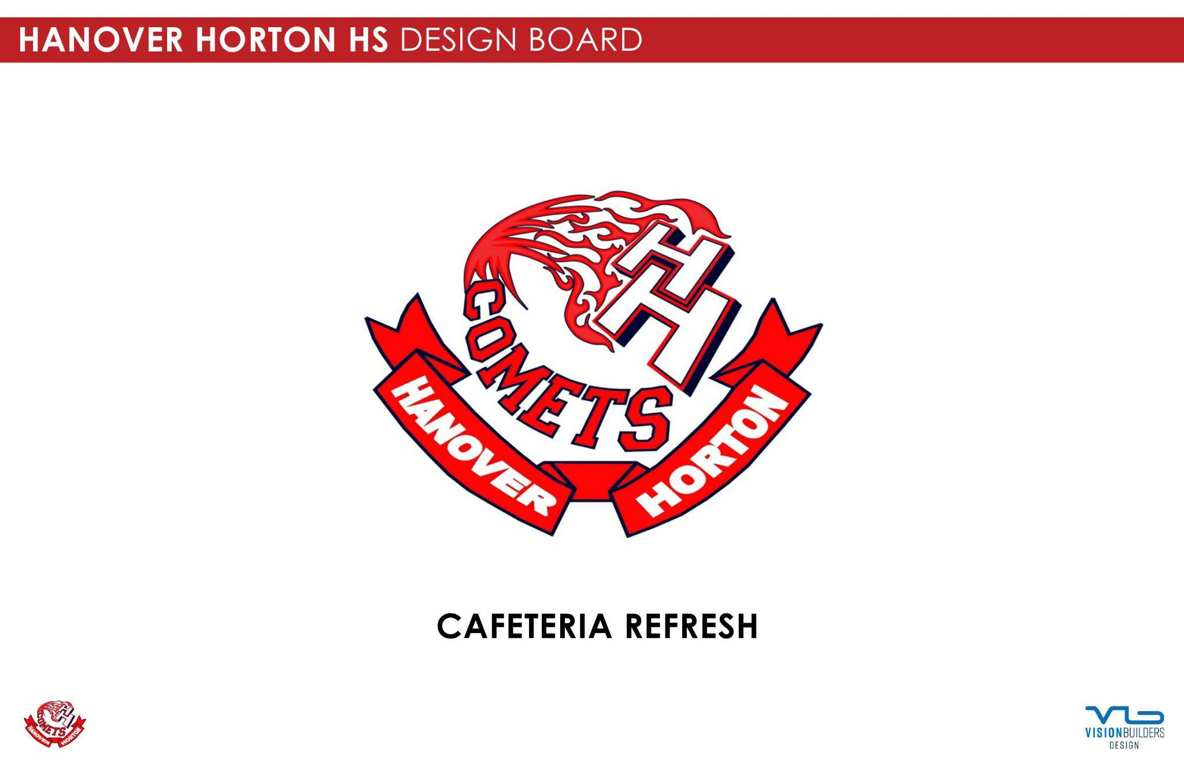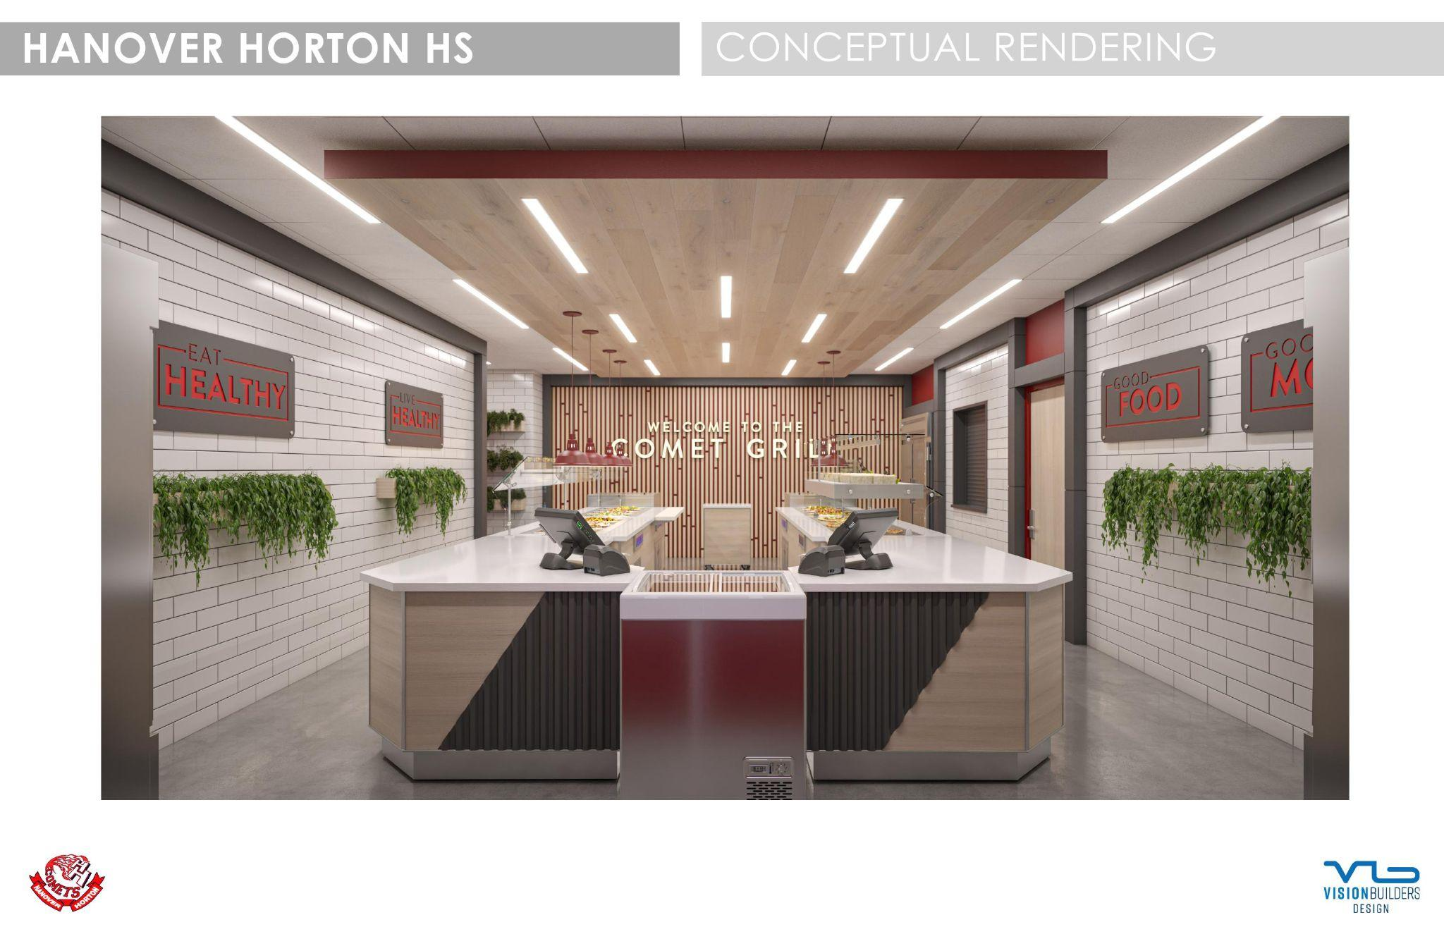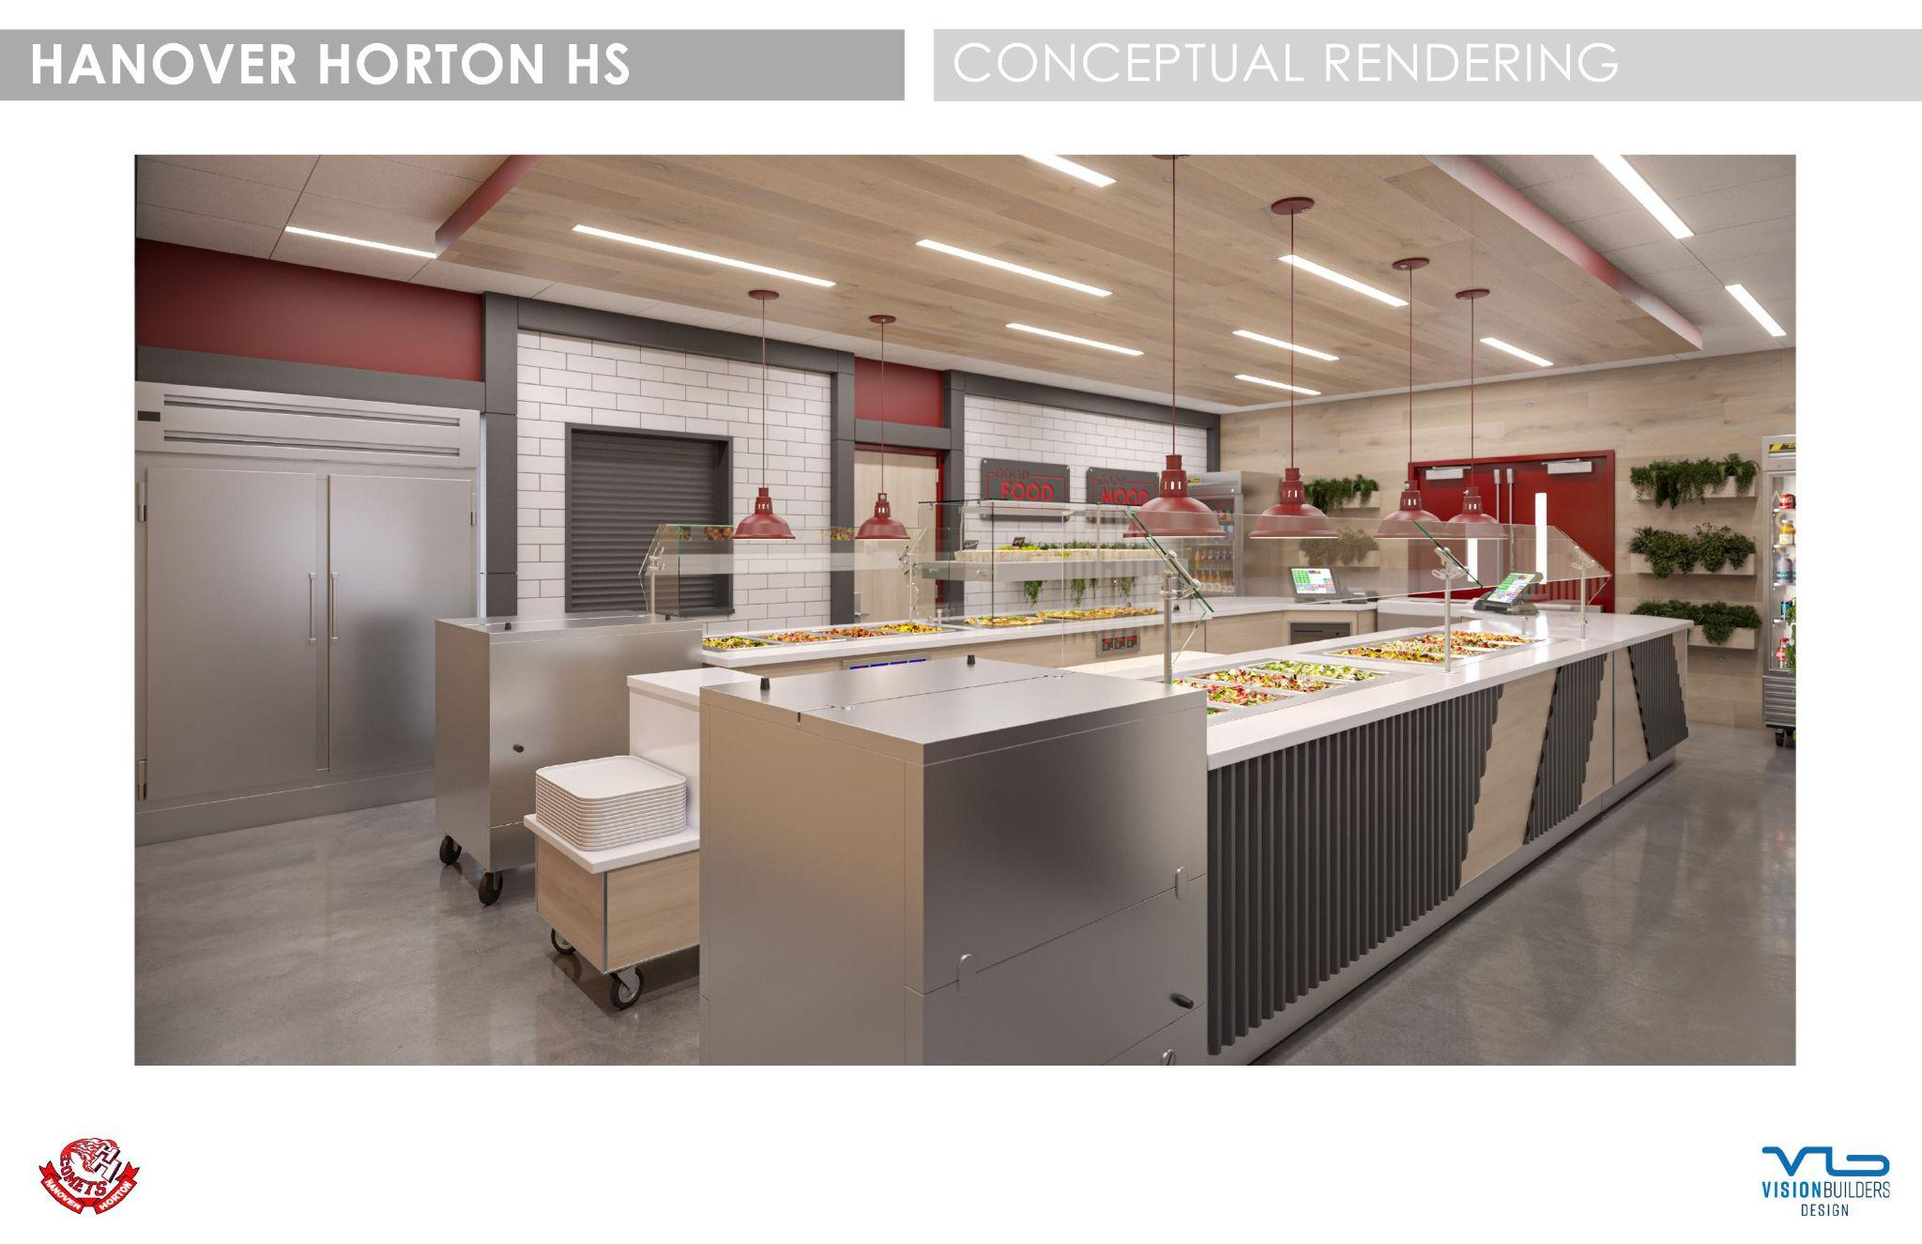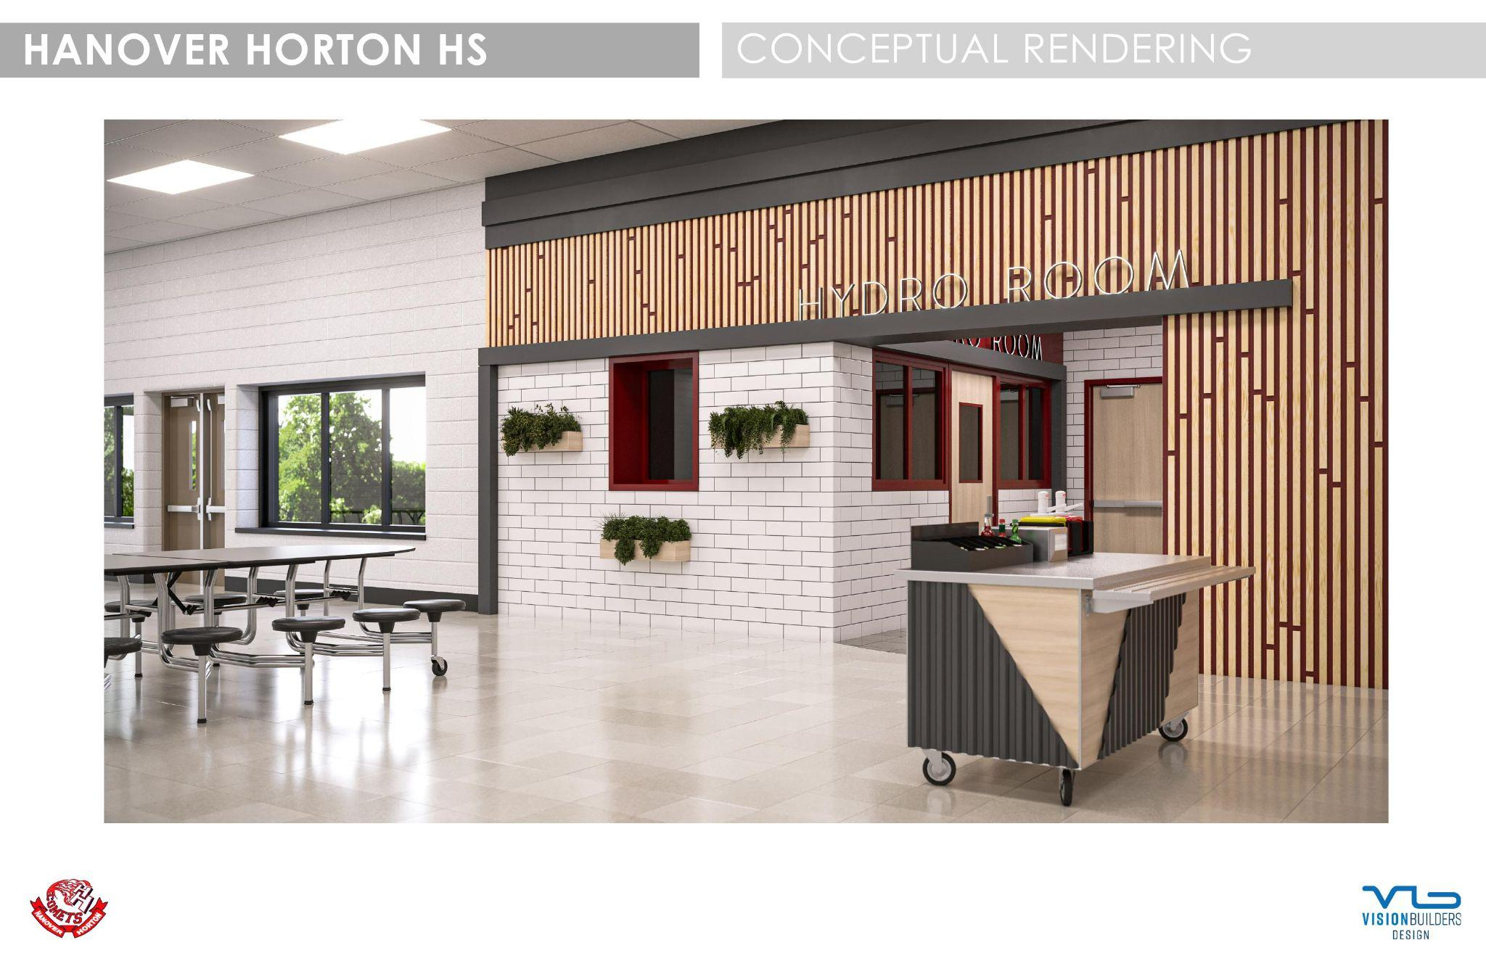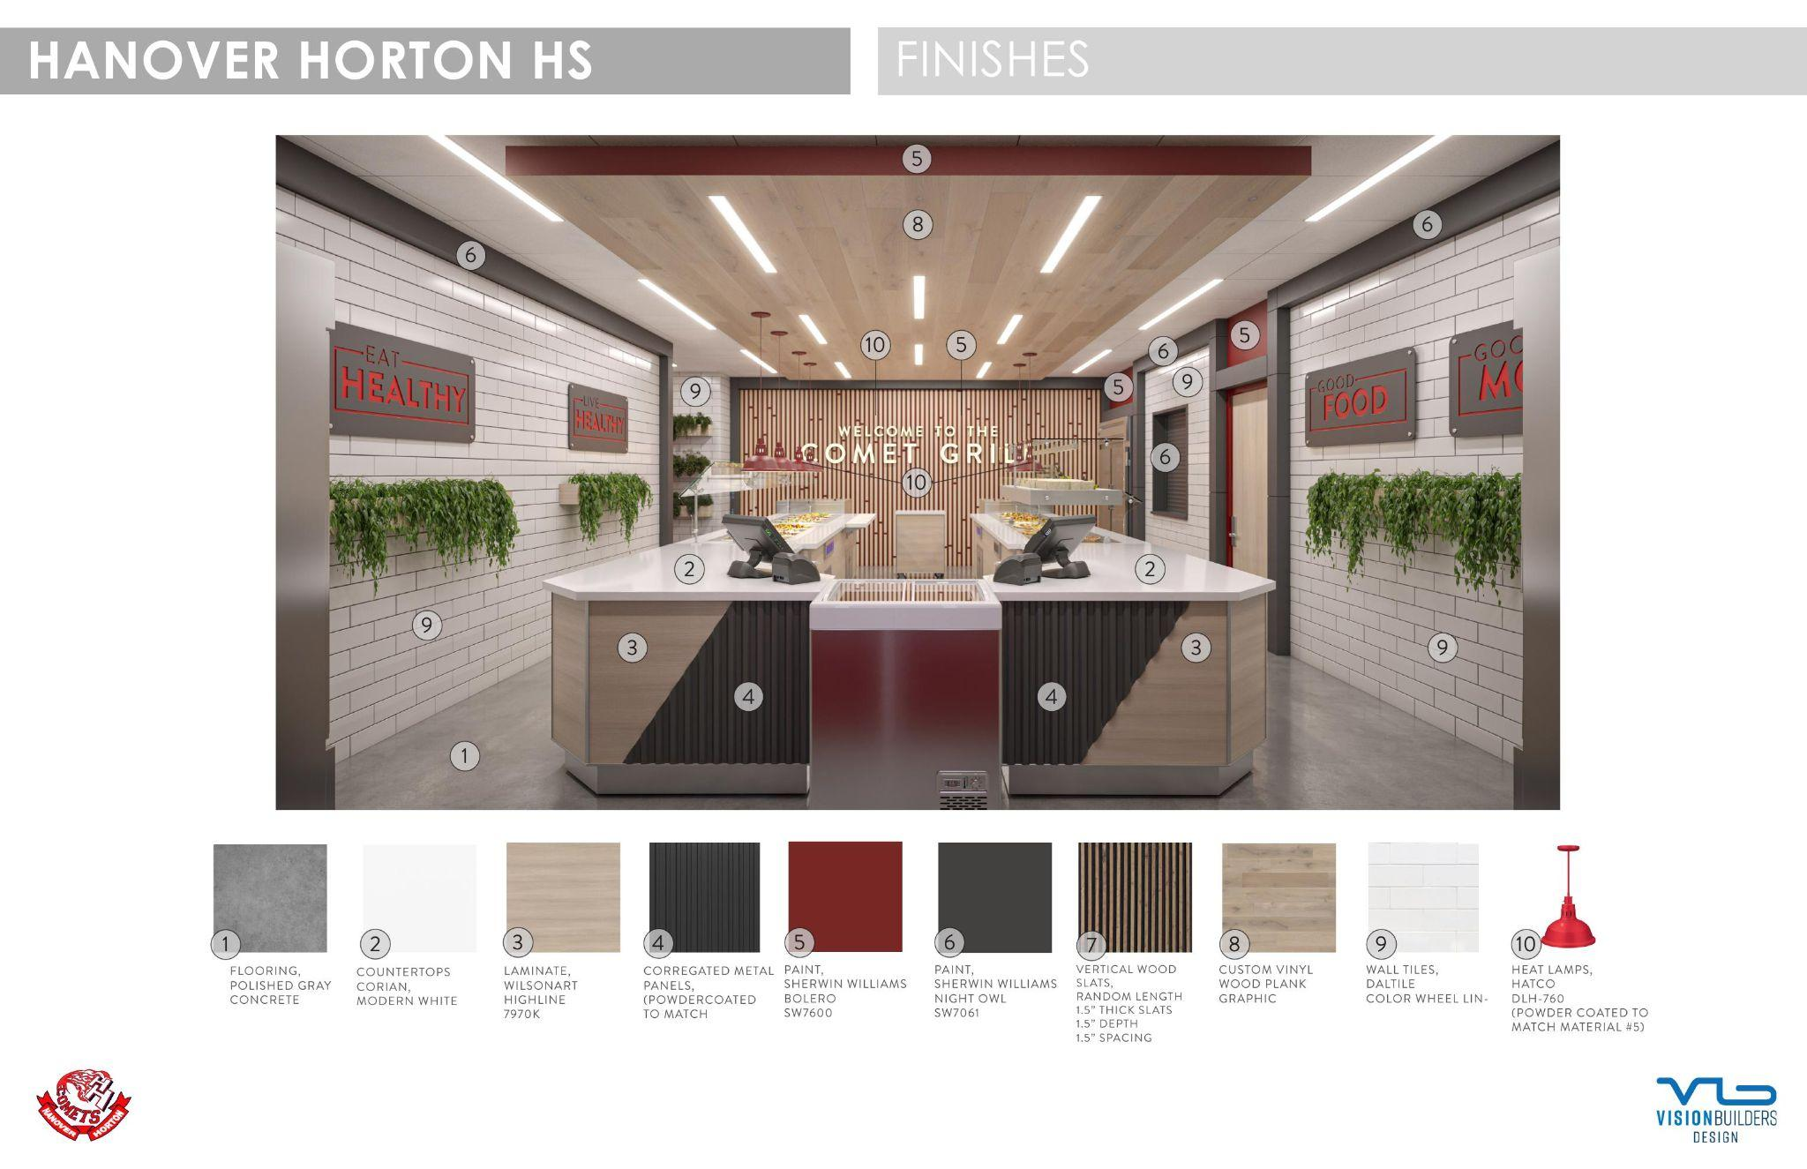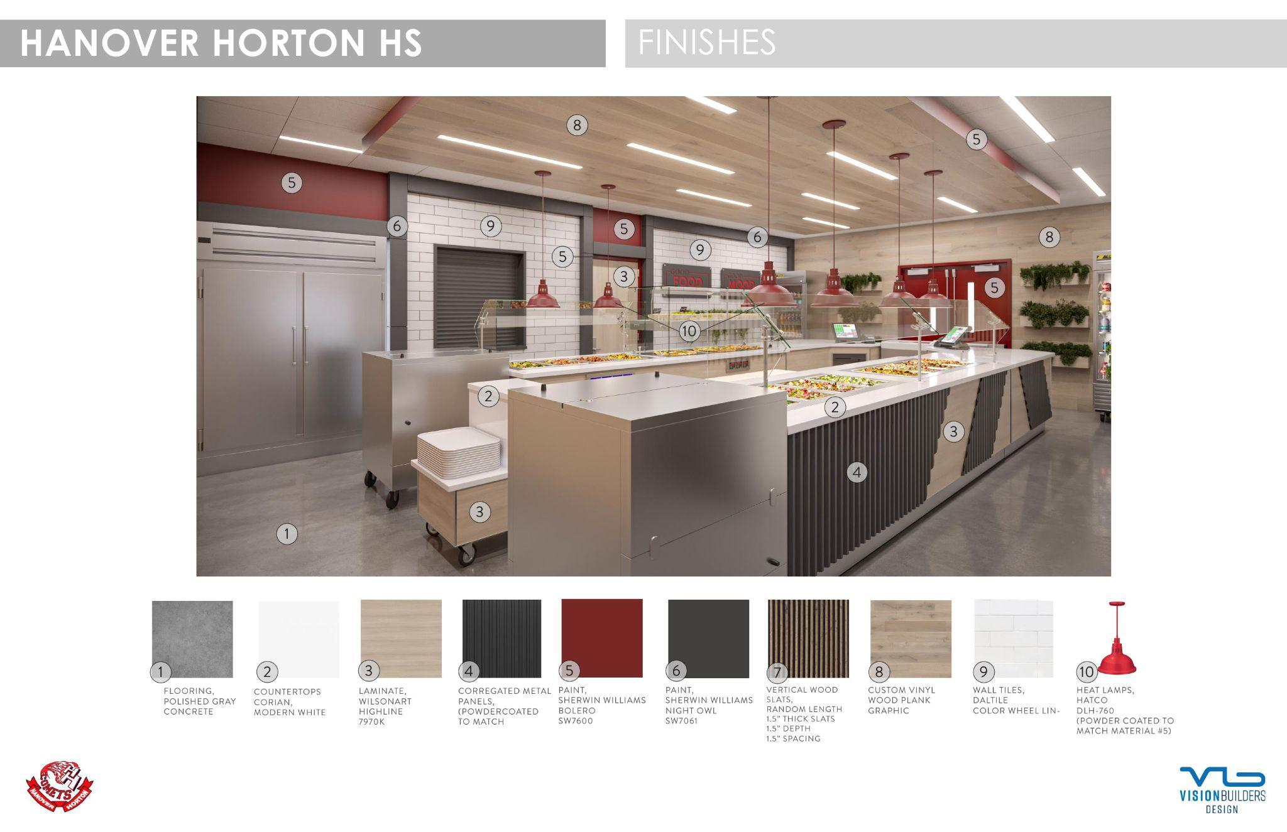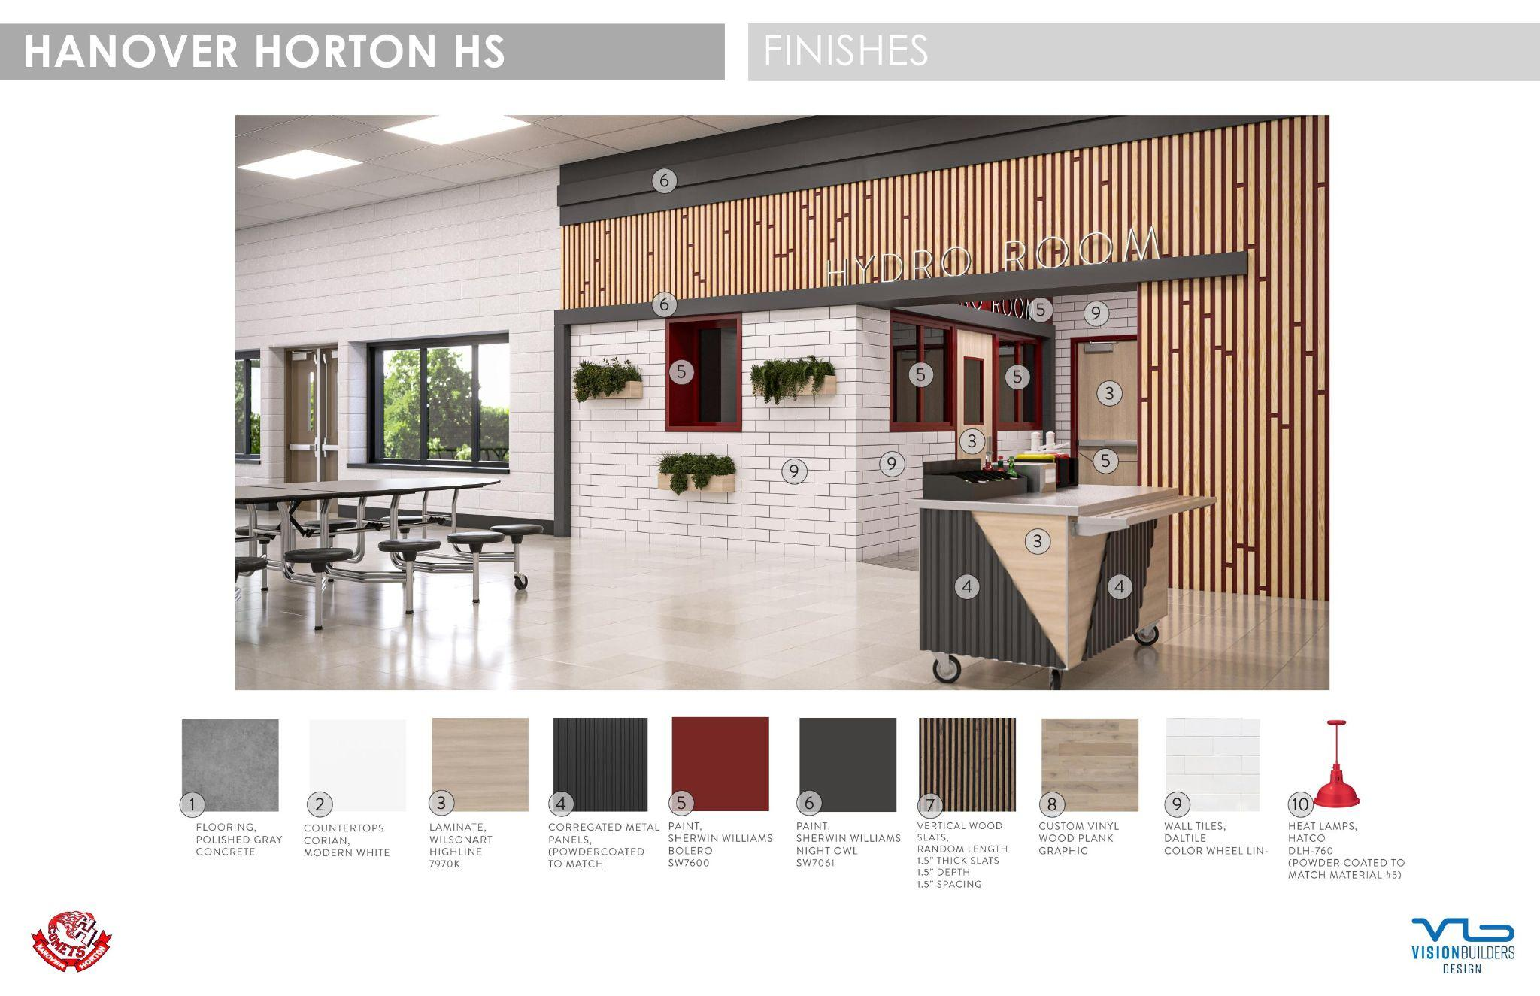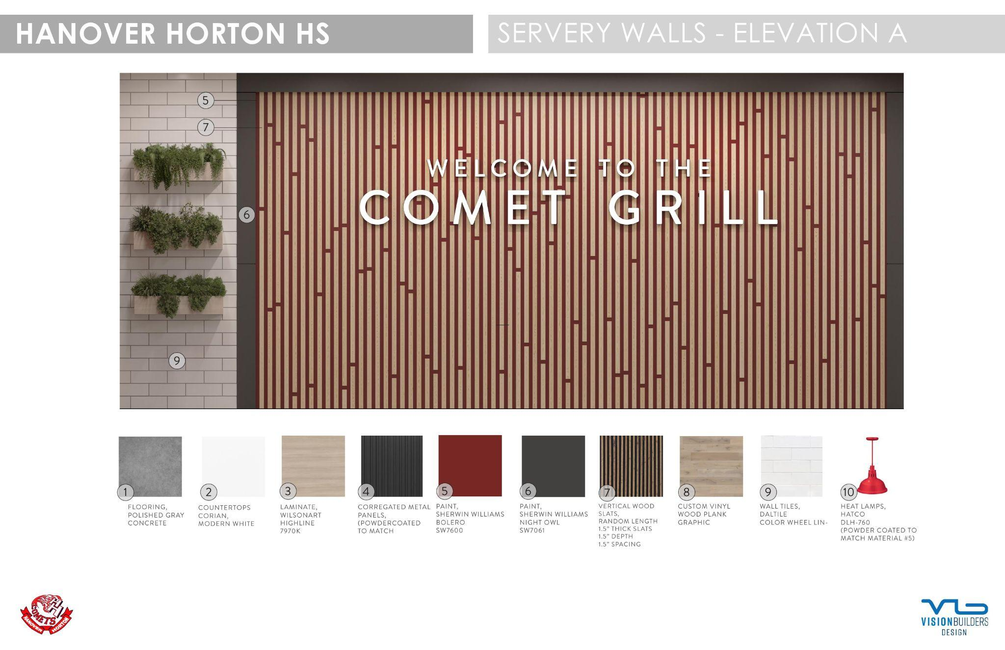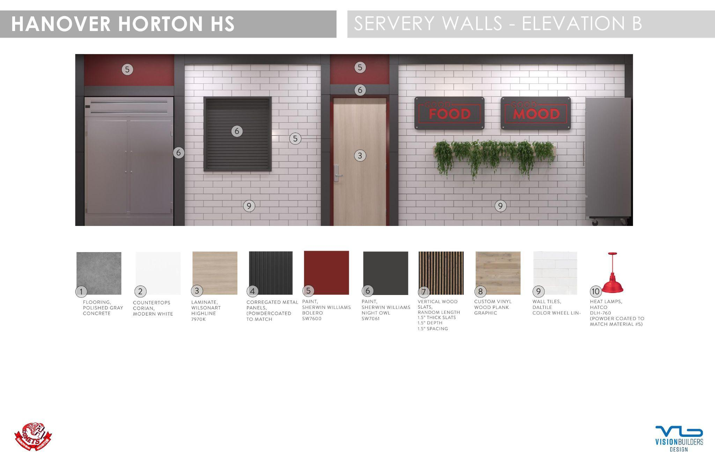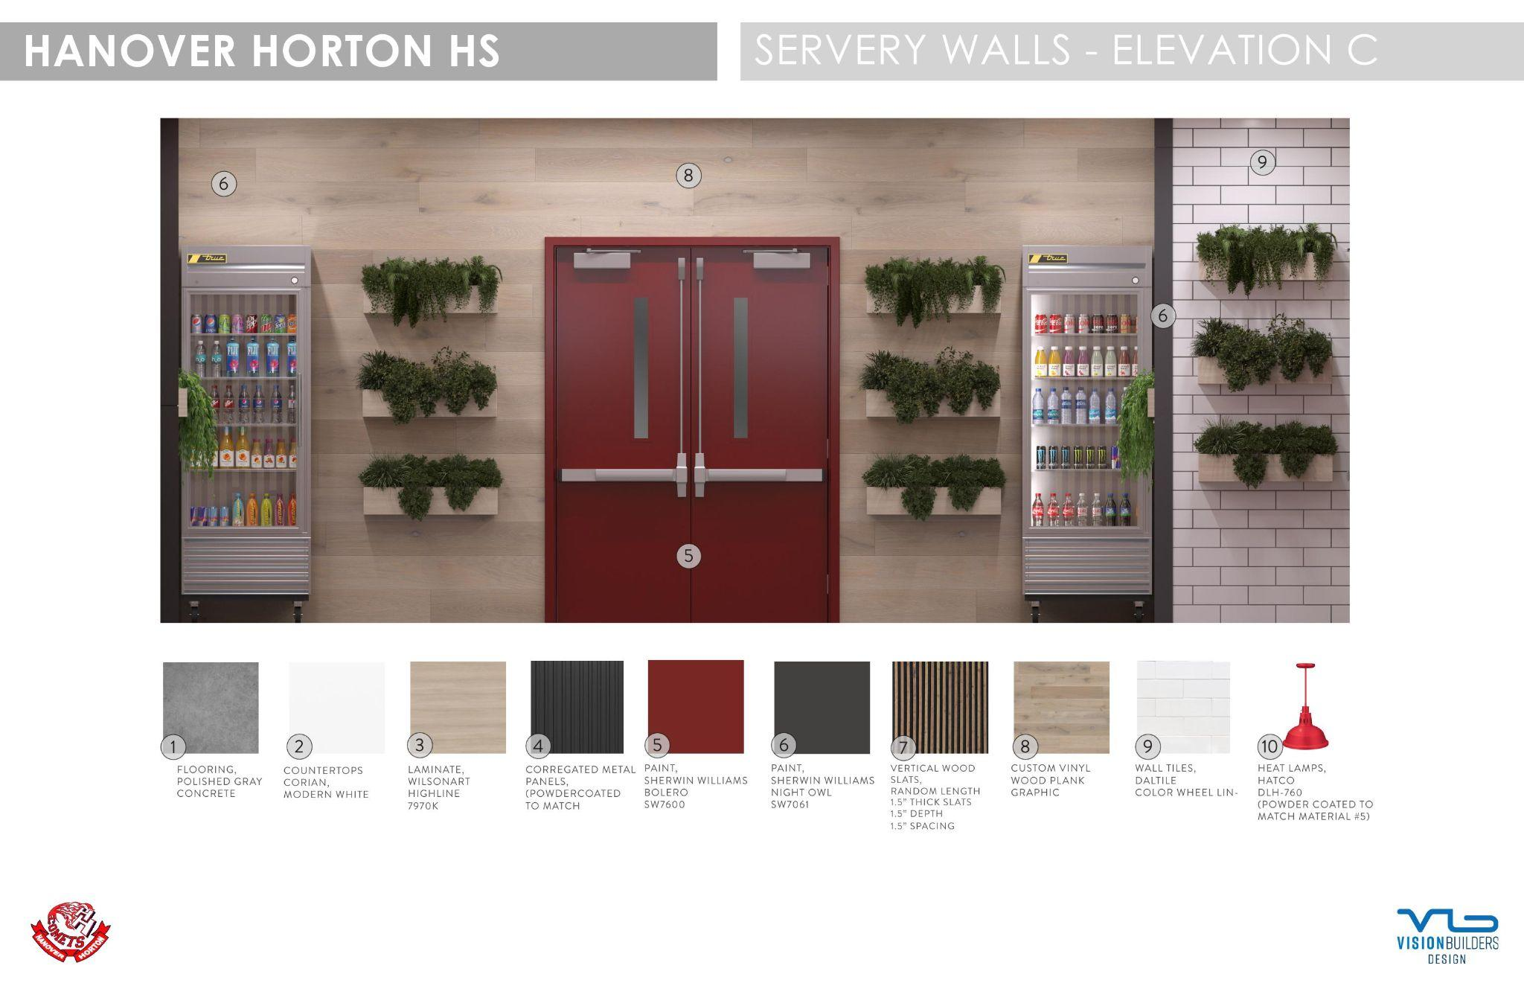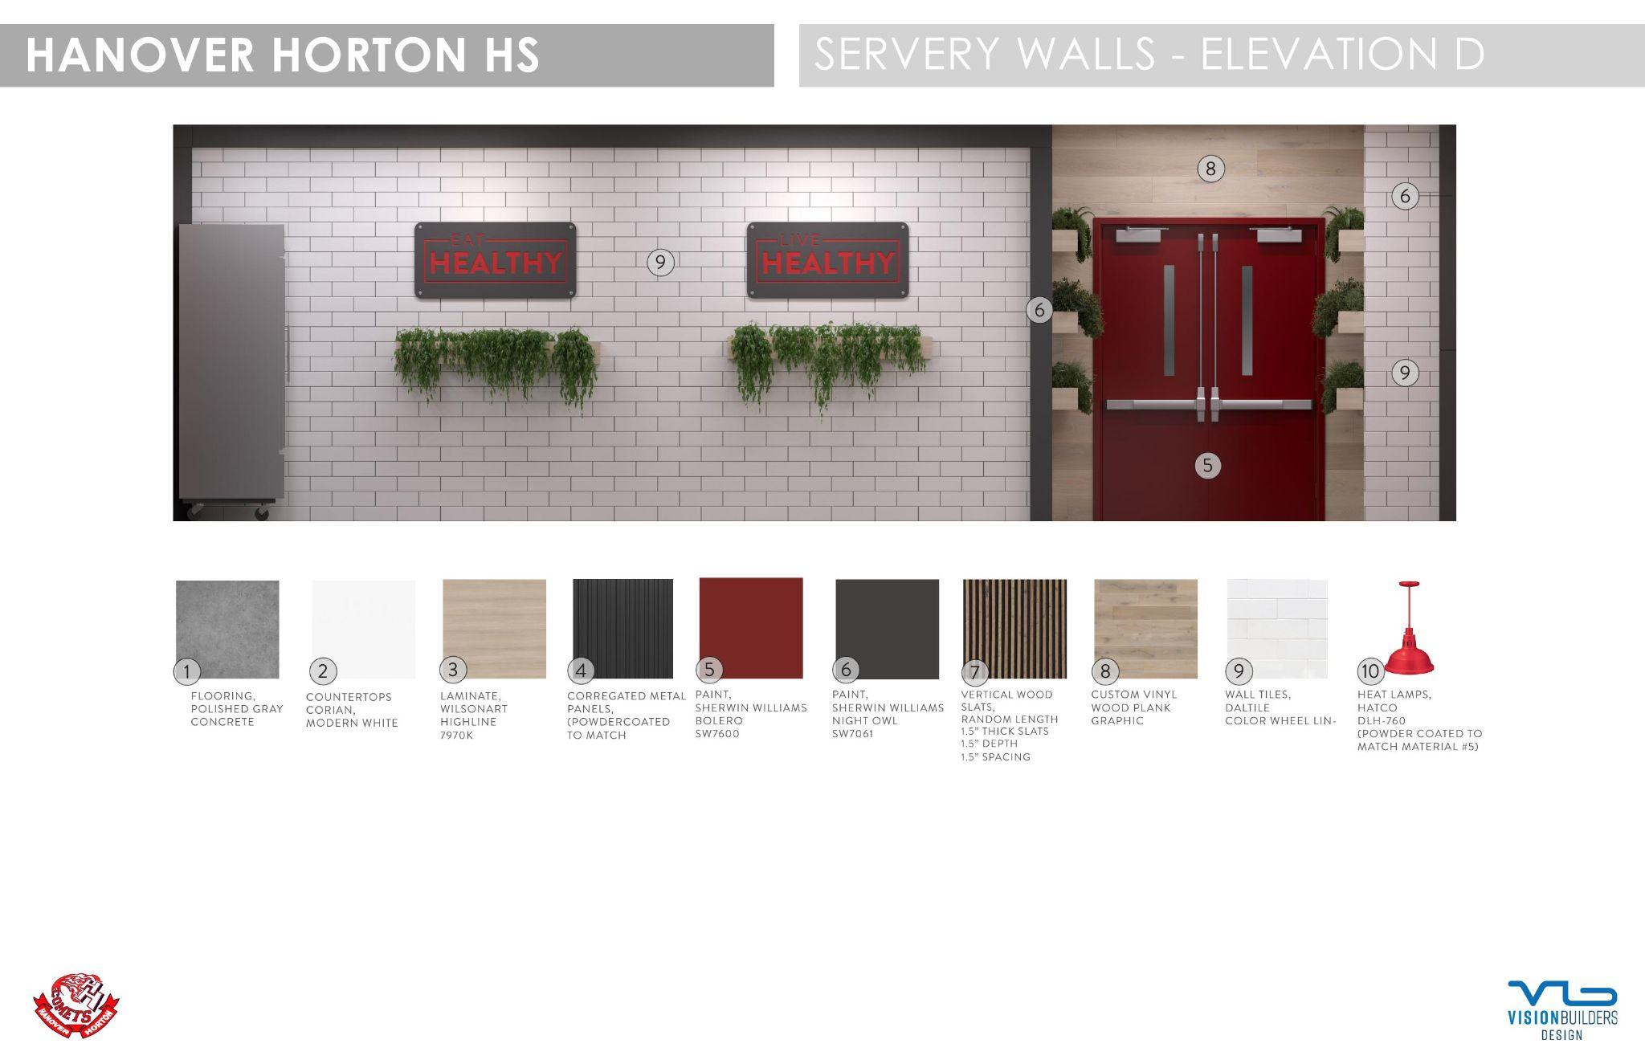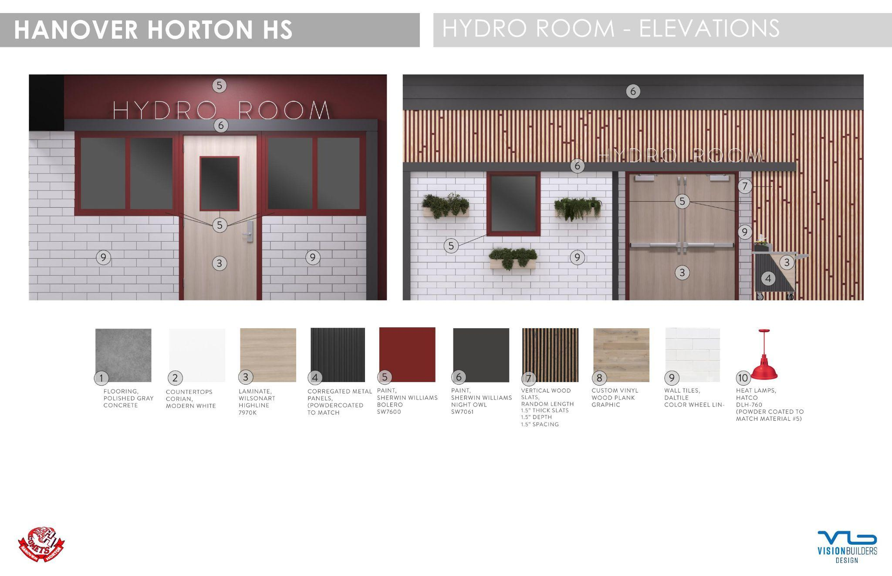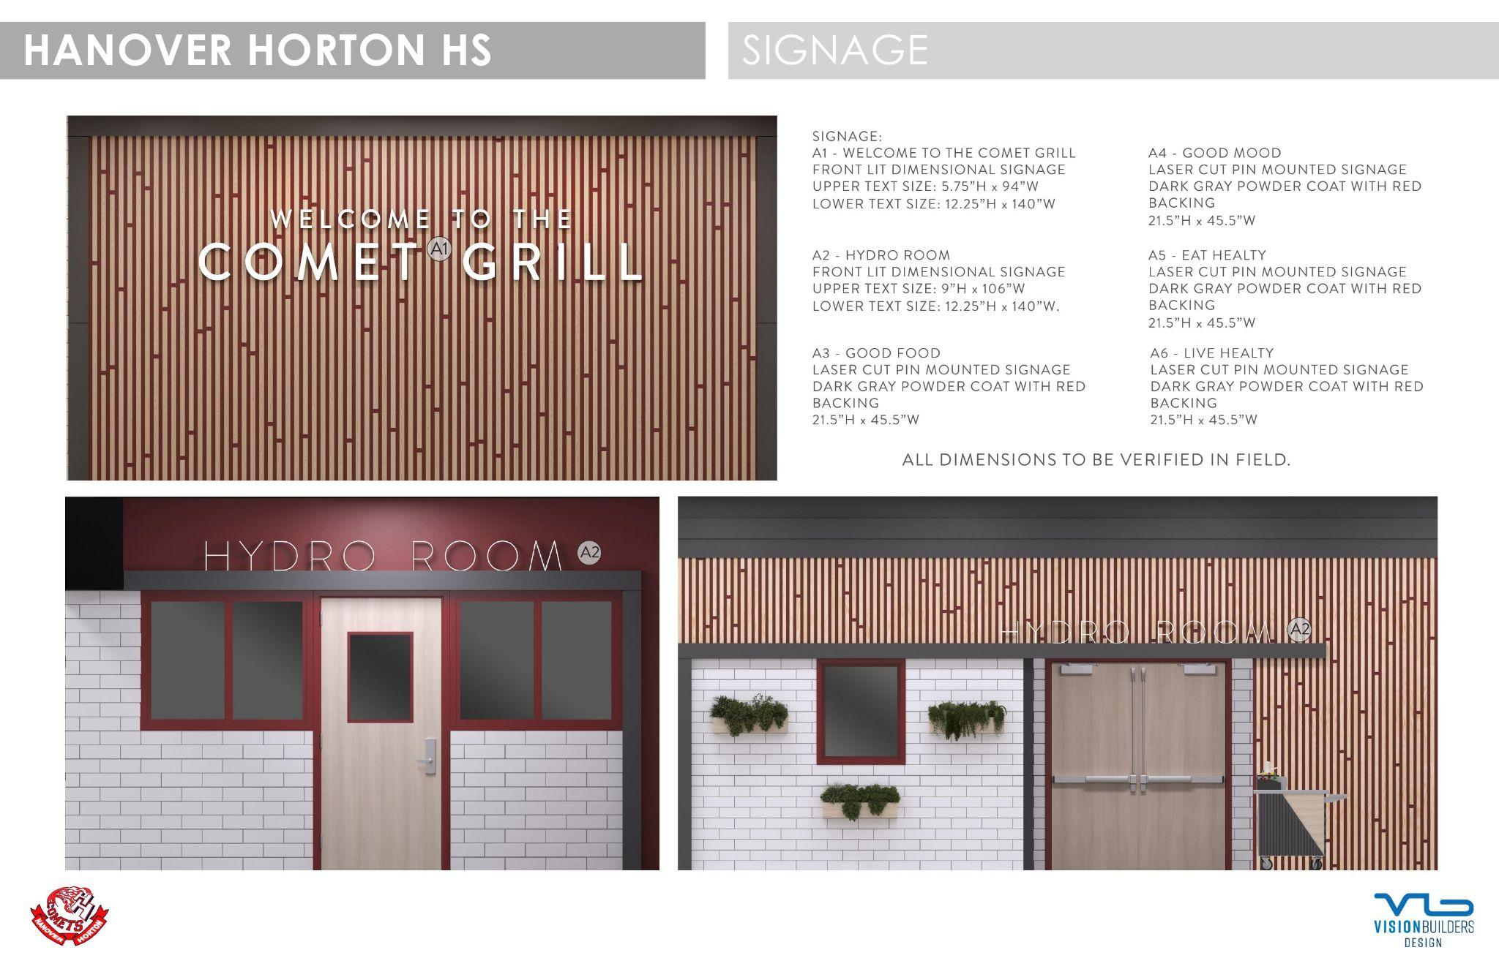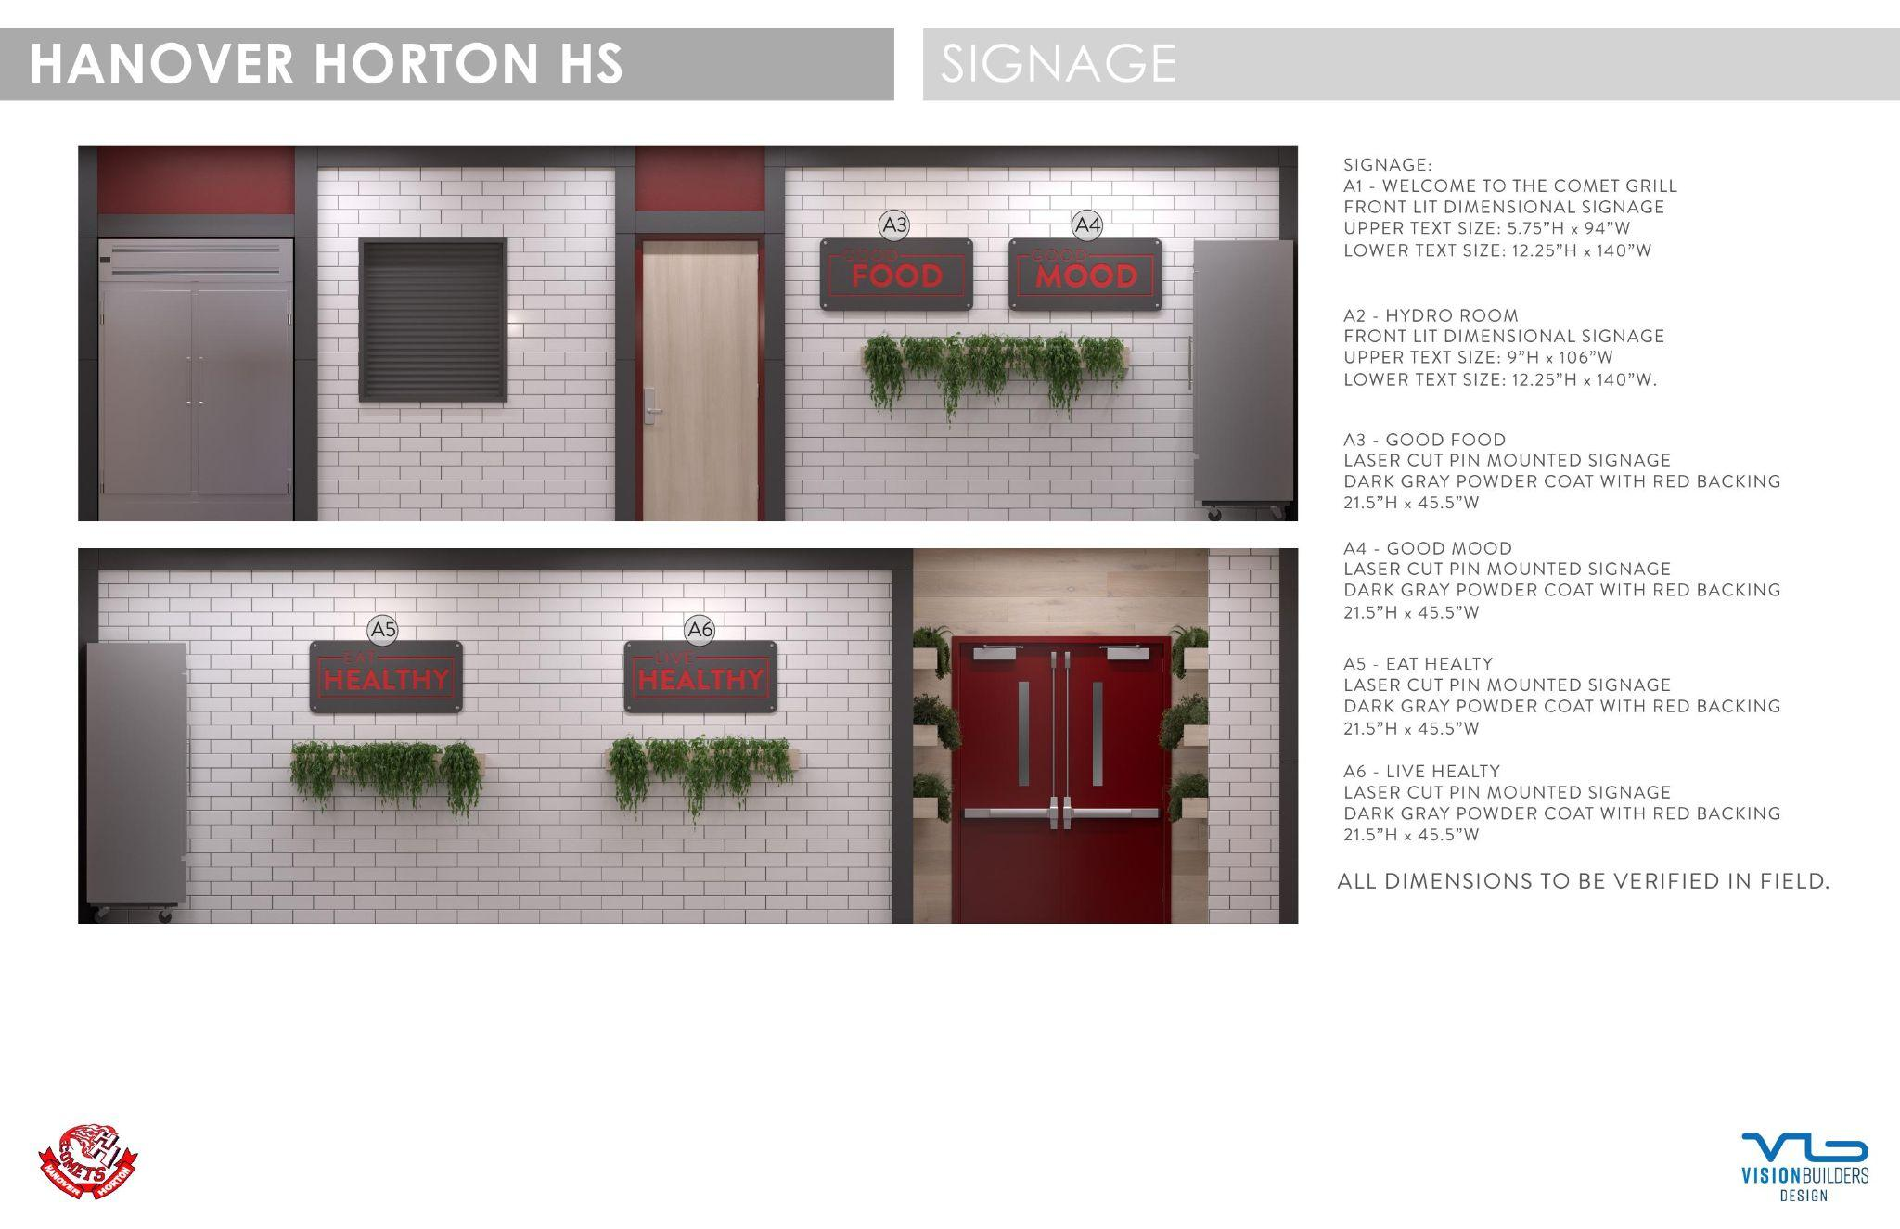

Attachment B: Form of Contract

CONTRACTOR AGREEMENT

This Agreement (“Agreement”) is made this ____ day of ___________, 2026 by and between Hanover-Horton School District, a Michigan general powers school district, organized and operated pursuant to the Michigan Revised School Code, whose address is 10000 Moscow Rd, Horton, MI, 49246 (hereinafter referred to as the “District” or "Owner"), and __________________, a Michigan ___________, whose address is __________________________ (hereinafter referred to as “Contractor”), for services related to providing and installing serving line improvement & modifications at the District, all in accordance with the terms and conditions herein.

RECITALS

WHEREAS, the District desires to install/purchase serving line improvement & modifications ("Project") and has issued Bidding Documents for such purpose (“Bidding Documents”);

WHEREAS, Contractor is an entity which has represented to have the personnel, expertise, training, capacity and qualifications to perform the Project and has submitted a bid in response to the Bidding Documents;

WHEREAS, the District and Contractor desire to enter into this Agreement to authorize and require the Contractor to perform the Project and any other duties identified herein.

NOW THEREFORE, in consideration of the mutual promises and benefits contained herein, the parties agree as follows:

SECTION 1 – INCORPORATION OF DOCUMENTS

1.1 The RFP, Bidding Documents and District-accepted portions of the Contractor’s bid (“Bid”) are incorporated herein by reference as if fully restated herein. In the event of any inconsistency between or among the RFP, Bidding Documents, the Bid, this Agreement, or any other contract document (collectively, the "Contract Documents"), the provision that is more beneficial to the Owner (as determined in the Owner's sole discretion) shall be deemed to control.

SECTION 2 – DESCRIPTION OF SERVICES / RELATIONSHIP OF PARTIES

2.1 Contractor shall provide services related to the Project, as described in the documents identified in Section 1, as required by law, as may otherwise be subsequently agreed to by the parties in writing via amendment (“Services”). Contractor’s Services include those to be performed by Contractor, Contractor’s subcontractors and suppliers, and Contractor’s consultants and agents as enumerated in this Agreement and as reasonably necessary to complete the Project.

2.2 The work to be performed by the Contractor is generally described in the RFP and Bidding Documents, including Attachments, as well as all related and incidental services necessary to complete the Project.

2.3 Contractor’s services shall be performed as expeditiously as is consistent with professional skill and care and the orderly progress of the Project. Contractor shall perform its responsibilities and services in a manner consistent with applicable industry standards. Contractor shall submit for the Owner’s approval a schedule for the performance of Contractor’s services which shall not exceed time frames required by the Contract Documents except as such time frames may be properly extended by mutual written agreement of the parties. It is understood and agreed that minimizing disruption to the District’s operations is a critical scheduling consideration.

2.4 Contractor’s employees assigned to provide Services shall be fully certified, licensed and approved as necessary to lawfully perform the Services. Contractor shall at all times comply with applicable federal, state and local laws, rules, regulations and policies, including but not limited to those applicable to public school projects, as well as those related to safety, including but not limited to OSHA and MIOSHA as applicable. In the event of any inconsistency between or among code requirements, regulations, and interpretations, Contractor shall be required to comply with the most-stringent obligation(s). Contractor shall obtain and comply with all necessary permits and permissions to perform the work.

2.5 Contractor shall be responsible for all materials and equipment while in transit and until finally and properly installed. Contractor further agrees that any equipment installed pursuant to this Agreement shall be new and of good working order. Contractor shall indemnify and hold the Owner harmless from and against any and all claims of whatever kind or nature for damage to property or for personal injury, including death, and from and against any loss or liability in connection therewith, made by anyone arising out of the negligence or willful misconduct of Contractor under this Agreement, either by Contractor, any subcontractor of Contractor, or by anyone directly engaged or employed by Contractor, provided, however that Contractor shall have no liability hereunder, for any such claims, loss or liability to the extent they arise from or relate to the negligence or willful misconduct of the Owner.

2.6 In the performance of Services under this Agreement, Contractor (its agents, subcontractors and employees) shall be regarded at all times as performing services as an independent contractor of the District. Contractor shall be regarded, designated and considered to be the employer with respect to all individuals whom Contractor may select and assign to provide Services under this Agreement.

2.7 Within the meaning of all applicable federal, state and local laws, including but not limited to, employment taxes, income taxes, labor relations acts, employment discrimination laws, minimum wage and overtime laws, and workers' compensation laws (collectively, the "Employment Laws"), Contractor is and shall be deemed to be the sole employer of all personnel used to provide services on behalf of Contractor pursuant to this Agreement (the "Contractor Personnel"), and its relationship with the Owner shall be deemed to be that of an independent contractor and not that principal and agent, servant, or employer and employee. As the employer of the Contractor Personnel, Contractor shall: (a) have the power to hire, discipline, recruit, train and terminate Contractor Personnel; (b) instruct the Contractor Personnel on when, where and how to perform their duties: (c) determine the amount of frequency of wage, benefit, salary, bonus and other payments to Contractor Personnel; (d) determine and pay the amount, if any, of reimbursement for business and/or traveling expenses of Contractor Personnel; (e) pay and file with all appropriate governmental entities all necessary payroll information, taxes and deductions, including but not limited to, federal, state and local income taxes, social security taxes, and unemployment taxes; (f) comply with the Employment laws; and (g) pay any and all workers' compensation and other insurance costs and premiums applicable to employers.

2.8 Contractor is expected to coordinate the timing, location, and performance of Services with the District representative and/or any other District administrator identified to the Contractor in writing. The intent of this paragraph is not to direct the Contractor's work, but only to ensure the efficient and smooth performance of same in light of the District's ongoing operations.

SECTION 3 – FEES, INVOICE AND PAYMENT

3.1 In consideration of Services properly provided by Contractor under this Agreement, the District will pay to Contractor ________________________________ Dollars ($___________). No additional fees, compensation, or costs of any kind shall be paid to Contractor, except and to the extent agreed to by the parties in writing.

3.2 Invoices shall be submitted no more frequently than monthly and shall coincide with the value of work performed. The District will remit payment on undisputed invoices or undisputed portions of invoices within thirty (30) days of receiving the invoice, but in no event shall a payment be made if such payment will result in the Contractor receiving an amount that exceeds the value of services performed to date.

3.3 Without regard to Section 3.2, the District shall be entitled to retain ten percent (10%) of any amounts paid until the Contractor has successfully and finally completed its Services.

SECTION 4 – INDEMNIFICATION AND INSURANCE

4.1 Contractor shall indemnify and hold the District (and its officers, administrators, employees, and agents) harmless from and against all liabilities, damages, fines, penalties, demands, forfeitures, claims, suits, causes of action or any other liabilities or losses, including all costs of defense, settlement and prosecution along with attorney, expert and other professional fees, arising out of or related to any negligence, wrongful act or breach of this Agreement or the obligation of Contractor or any of its employees or others for whom it is responsible in connection with the performance or non-performance of the Agreement.

4.2 Contractor agrees to procure and maintain insurance coverage in types and amounts reasonably required by the District and in no event less than identified in the Bid. Contractor agrees to provide the District certificates of insurance evidencing such coverage prior to commencing any Services. Insurance shall be obtained and maintained from an insurance company licensed to sell insurance in the State of Michigan with an A+ A.M. Best rating, or equivalent. Insurance coverage shall not be reduced or eliminated without at least sixty (60) days prior written notice to the District.

4.3 Contractor's insurances shall be obtained prior to the commencement of Services and shall be maintained either: (a) for at least one year following final completion if occurrence-based, and/or (b) for at least seven years following final completion if claims-made. The District shall be identified as an additional insured on all applicable insurances.

4.4 If the contract sum identified in Section 3.1 is $50,000 or more, Contractor shall provide performance and payment bonds in an amount equal to 100% of the contract sum. The bonds shall be provided at no additional cost to the District, with the cost thereof deemed included within the Contractor’s bid. If the contract sum identified in Section 3.1 is less than $50,000, the District may still require the Contractor to provide performance and payment bonds, but the cost thereof shall be deemed an additional reimbursable expense. In all other respects, bonds shall minimally comply with MCL 129.201, et seq.

SECTION 5 – EMPLOYEES AND SUBCONTRACTING

5.1 The District reserves the right to approve the identity of project representatives of the Contractor and any subcontractors. No subcontractor shall be used without the District’s prior written approval. The District shall have the right to request removal of any employee of the Contractor or a subcontractor from the project at the District’s direction upon 2 weeks' notice, subject to Contractor's status as employer.

5.2 In the performance of the Agreement it may be necessary for Contractor to subcontract part of the work to others. The Contractor will inform the District as to which subcontractors will be used. Subcontractor use shall be subject to the written approval of the District. The Contractor will be fully responsible to the District for the acts and omissions of subcontractors and of all persons whether directly or indirectly employed by the Contractor. Nothing in this Agreement shall create any contractual relationship between any subcontractor and the District. The Contractor shall not assign, transfer, convey, or otherwise dispose of the Agreement, or any part thereof, or the Contractor’s right, title, or interest in same without the prior written consent of the District. The Contractor shall not assign any of the monies due or to become due and payable under the Agreement without prior written consent of the District.

SECTION 6 – NONDISCRIMINATION

6.1 Contractor shall not discriminate against an employee or applicant for employment with respect to hire, tenure, terms, conditions, or privileges of employment, or a matter directly or indirectly related to employment, because of race, color, religion, national origin, age, sex, weight, or marital status and other employment matters described by Title VII of the Civil Rights Act of 1964 (Pub. L. 88-352. Breach of this covenant may be regarded as a material breach of the agreement.

SECTION 7 – OWNER’S RIGHT TO CORRECT DEFICIENCIES

7.1 If the Contractor shall neglect to perform the work properly, or should it refuse to remedy any defects in the work due to inferior quality or installation, or should it in any manner fail to perform any provision of the Agreement, the District, after 7 days' notice to the Contractor, may correct such deficiencies at Contractor’s cost and may deduct the cost thereof from any payment due the Contractor. The remedy described in this section is not exclusive and shall have no effect on the Owner’s ability to seek recovery for, among others, breach of contract, breach of warranty, and/or performance bond claims.

SECTION 8 – TIME FOR PERFORMANCE

8.1 Time is of the essence of this Agreement. The Contractor acknowledges and agrees that the performance of Services shall commence on or before June 15th, 2026 and shall be finally and sufficiently completed on or before September 30th, 2026. The District reserves the right to seek damages for any Contractor delays. For any delays caused to the Contractor, the Contractor's sole remedy shall be an extension in the deadline for performance.

SECTION 9 – DISPUTE RESOLUTION

9.1 The parties shall first attempt to resolve disputes informally and, if unsuccessful, through non-binding mediation. Mediation will be conducted in accordance with the Construction Industry Mediation Rules of the American Arbitration Association then in effect. Any claim or dispute not resolved by binding mediation shall be subject to litigation (or, if the parties agree in writing, arbitration).

9.2 A demand for mediation may be filed along with a complaint in litigation or a demand for arbitration, as applicable, but the process of non-binding mediation shall proceed first (so long as permitted by the applicable court or arbitrator). Any demand for mediation filed prior to a complaint in litigation or a demand for arbitration shall toll the statute of limitations for all applicable claims until the mediation process has been completed, successfully or unsuccessfully.

9.3 In the event of any mediation, arbitration or litigation arising out of or relating to this Agreement, Owner reserves the right to require that the mediation, arbitration or litigation, as applicable, be conducted in the general area where the Owner’s principal place of business is located. Any mediation with respect to this Agreement shall be non-binding. Any agreements reached in mediation shall be binding in accordance with law.

9.4 The Owner reserves the right in its discretion to require consolidation or joinder of any dispute arising out of or relating to this Agreement which another mediation, arbitration or litigation involving a person or entity not a party to this Agreement, in the event the Owner believes in its sole discretion that such consolidation or joinder is necessary in order to resolve a dispute or avoid duplication of time, expense or effort.

9.5 The Contractor shall include similar dispute resolution provisions in all agreements with subcontractors, sub-consultants, suppliers, or fabricators so retained, thereby providing for a consistent method of dispute resolution between and among the parties to those agreements.

9.6 As a condition precedent to any claim, mediation, arbitration, litigation or other cause of action being brought by the Contractor against the District, the Contractor shall notify the District in writing of any contractual or other dispute within 21 days of the circumstances giving rise to same. The failure to timely provide such notice shall be an irrevocable waiver of any claim or cause of action. Claims and causes of action by the District shall be subject to the applicable statute of limitations under Michigan law, but in no event shall a claim by the District be deemed untimely if filed within six (6) years of final completion of the Services.

SECTION 10 – TAXES

10.1 The Contractor acknowledges that the District is a tax-exempt entity and any taxes incurred pursuant to performance of this Agreement, including but not necessarily limited to sales and use taxes, shall be the sole responsibility of Contractor.

SECTION 11 – WARRANTIES

11.1 The Contractor shall provide the following warranties at no additional cost to the Owner: ______________________________________________________________.

11.2 In addition to, and not in substitution of, Section 11.1, the Contractor shall assign and forward to the Owner all applicable manufacturers' warranties for any equipment, software or materials relevant to the Project and Services.

SECTION 12 – TERMINATION

12.1 The Owner may terminate this Agreement upon seven (7) calendar days' prior written notice to the Contractor. If the Agreement is terminated prior to completion of the Services, Contractor shall provide a final report based on the value of the Services reasonably and properly performed as of the date of termination, and the Owner shall make payment for all services properly performed prior to termination, but in no event shall such sum exceed the fee described in Section 3.1.

SECTION 13 – CONFIDENTIALITY

13.1 If Contractor receives information of the Owner that is "confidential" or "business proprietary," Contractor shall keep such information strictly confidential and shall not disclose it to any other person except to its employees, those who need to know the content of such information in order to perform services solely for this Project, or its consultants whose contracts include similar restrictions. The parties acknowledge that the Owner cannot provide similar confidentiality protection due to the applicable of the Michigan Freedom of Information Act and the Michigan Open Meetings Act, among others.

SECTION 14 -- MISCELLANEOUS

14.1 Neither party shall assign this Agreement nor its rights and duties hereunder nor any interest herein without prior written consent from the other.

14.2 This Agreement, including all attachments and documents incorporated herein by reference, constitutes the entire agreement between the parties regarding its subject matter and supersedes any prior or contemporaneous understandings or agreements with respect to the services contemplated.

14.3 None of the terms and provisions of this Agreement may be modified, waived, or amended in any way except by written amendment, change order, or construction change directive.

14.4 Failure by either party at any time to require performance by the other party or to claim breach of any provision of this Agreement shall not be construed as a waiver of any subsequent breach nor affect the validity and operation of this Agreement, nor prejudice either party with regard to any subsequent action to enforce the terms of this Agreement.

14.5 This Agreement shall be interpreted and enforced under the laws of the State of Michigan.

14.6 If any provision of this Agreement should be invalid, illegal or unenforceable in any respect, the validity, legality and enforceability of the remaining provisions of this Agreement shall not in any way be affected, impaired or prejudiced thereby.

14.7 This Agreement may be executed in one or more counterparts, each of which shall be deemed to be an original, but all of which constitute one and the same agreement.

14.8 As a part of its services, the Contractor shall provide call-back services for twelve (12) months following completion of the Project.

14.9 Notwithstanding any provisions within the Contract Documents, nothing shall be deemed a waiver of any immunity granted to Owner by law or statute, including but not necessarily limited to, governmental immunity under MCL 691.1407.

14.10 Contractor shall not be entitled to additional compensation in the event it is necessary to extend the Project completion date because the Project is delayed due to conditions beyond the control of the Owner, such as strikes, weather, material shortages, site conditions, etc.

14.11 Contractor agrees to retain permanent records relating to the services performed for a period of at least six (6) years following submission of the construction documents, during which period the records will be made available to the Owner upon request.

SECTION 15 – AUTHORIZATION

15.1 The Agreement has been duly authorized, executed and delivered by the parties and constitutes a legal, valid and binding obligation upon each of them, enforceable in accordance with its terms. Each person placing his/her signature below represents and warrants that he/she is the signatory duly authorized to execute this Agreement on behalf of the District or Contractor, as is respectively applicable.

By: _______________________________ By: ______________________________

Its: _______________________________ Its: ______________________________

Date: _____________________________ Date: ____________________________
Attachment D – Familial Disclosure Form
Required by MCL 380.1267
TO: Hanover-Horton School District ("The District")
FROM: [Insert Bidder/Company Name] ("The Bidder")
The undersigned, the owner or authorized officer of the Bidder, represents and warrants that they have reviewed the list of the District's Board of Education members and its Superintendent. The Bidder further certifies that no familial relationship exists between the owner or any employee of the Bidder and any member of the Board of Education or the Superintendent, EXCEPT as specifically listed below:

1. DISCLOSURE OF RELATIONSHIP(S):
[ ] NO FAMILIAL RELATIONSHIP EXISTS: The undersigned Bidder has conducted a due diligence inquiry of its owners and employees and hereby certifies that no familial relationship exists between the owner(s) or any employee of the Bidder and any member of the Board of Education or the Superintendent.
[ ] FAMILIAL RELATIONSHIP DISCLOSURE: A familial relationship exists as disclosed in the table below:
Name of Bidder’s Employee | Position with Bidder | Name of Board Member/Superintendent | Nature of Relationship
Attach additional pages if necessary.

2. BIDDER CERTIFICATION:
By signing below, the Bidder acknowledges that any bid submitted without this sworn and notarized statement shall be considered non-responsive and will not be accepted by the District.
BIDDER NAME: _________________________________________________________
AUTHORIZED SIGNATURE: ____________________________________________
PRINTED NAME: _____________________________________________________
TITLE: __________________________________________________________________
DATE: _________________

3. NOTARY PUBLIC ACKNOWLEDGMENT:
STATE OF MICHIGAN ) COUNTY OF _______________)
Subscribed and sworn to before me this ______ day of ________________, 2026, by
_____________________________________________, (Name of Signer).
__________________________________________________
Notary Public, _________________________ County, Michigan.
My Commission Expires: _________________________
Acting in the County of: __________________________

Attachment E -- Iran Economic Sanctions Act Certification

I am the (title)_______________ of(bidder)____________________________, or I am bidding in my individual capacity ("Bidder"), with authority to submit a binding bid for the provision of services related to cafeteria furniture at Hanover-Horton School District. I have personal knowledge of the matters described in this Certification, and I am familiar with the Iran Economic Sanctions Act, MCL 129.311, et seq. ("Act"). I am fully aware that the school district will rely on my representations in evaluating bids.

I certify that Bidder is not an Iran-linked business, as that term is defined in the Act. I understand that submission of a false certification may result in contract termination, ineligibility to bid for three (3) years, and a civil penalty of $250,000 or twice the bid amount, whichever is greater, plus related investigation and legal costs.

_________________________________________
(signature)

_________________________________________
(printed)

_________________________________________
(date)

Attachment F -- Debarment and Suspension Certification

In accordance with 2 CFR 200.214
The undersigned bidder certifies, to the best of its knowledge and belief, that it and its principals:
- Are not presently debarred, suspended, proposed for debarment, declared ineligible, or voluntarily excluded from participating in this transaction by any Federal department or agency;
- Have not, within a three-year period preceding this bid, been convicted of or had a civil judgment rendered against them for fraud, antitrust violations, or theft;
- Are not presently indicted for or otherwise criminally or civilly charged by a governmental entity.
_________________________________________
(signature)

_________________________________________
(printed)

_________________________________________
(date)

Attachment G -- Lobbying Certification & SF-LLL Disclosure

In accordance with 31 U.S.C. 1352
The bidder certifies that no Federal appropriated funds have been paid or will be paid to any person for influencing or attempting to influence an officer or employee of any agency or a Member of Congress in connection with the awarding of this contract.
Disclosure Requirement: If any funds other than Federal appropriated funds have been used for lobbying activities, the bidder must complete and submit Standard Form-LLL (Disclosure of Lobbying Activities) alongside this certification.
Check one:
- [ ] No non-federal funds used (SF-LLL not required).
- [ ] Non-federal funds used (SF-LLL attached).
_________________________________________
(signature)

_________________________________________
(printed)

_________________________________________
(date)

Attachment H -- Davis-Bacon Act & MI Prevailing Wage Certification

Compliance with 40 U.S.C. 3141-3144 and MI LEO Schedules
The General Contractor hereby certifies that it will comply with the Davis-Bacon Act. All laborers and mechanics employed upon the site will be paid unconditionally, and not less than once a week, the full amount of wages and bona fide fringe benefits due.

_________________________________________
(signature)

_________________________________________
(printed)

_________________________________________
(date)

Attachment I – Buy American Certification

In accordance with 7 CFR 210.21(d) and 220.16(d)
The Vendor certifies that it will comply with the Buy American provision, ensuring that all equipment and agricultural commodities provided are produced in the United States.
Exception Clause: If a non-domestic product is proposed, the Vendor must submit a "Buy American Exception" form and receive written District approval prior to the contract award. Documentation for the origin of all equipment must be available upon request.

_________________________________________
(signature)

_________________________________________
(printed)

_________________________________________
(date)

Attachment J – Clean Air and Water Certification

Compliance with Clean Air Act & Federal Water Pollution Control Act
The Vendor agrees to comply with all applicable standards, orders, or regulations issued pursuant to the Clean Air Act (42 U.S.C. 7401-7671q) and the Federal Water Pollution Control Act as amended (33 U.S.C. 1251-1387). The Vendor agrees to report any violations to the Federal awarding agency and the Regional Office of the Environmental Protection Agency (EPA).

_________________________________________
(signature)

_________________________________________
(printed)

_________________________________________
(date)

