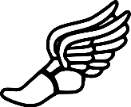
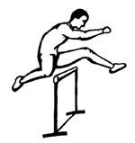
Spring Sports Announcement

Boy’s Golf: Will start Tuesday March 14 at 6:00 pm with a parent/player meeting in the library.

Girls’ soccer: practice will be Monday March 13 at 5:00 pm

Baseball: begins Monday March 13 at 5:00 pm for freshman and sophomores and 7:00 pm for juniors and seniors in high school gym

Track: Begins Monday March 13 at 3:30 pm on the track.

Softball: Begins Monday March 13 at 2:30 in the middle school gym

Physicals: All spring sport athletes must have a physical on file before tryouts or practice.

Life of an Athlete: All athletes must complete a Life of an Athlete meeting before competition. There will be a meeting Thursday March 16 at 7:00 pm in the high school library. A parent must accompany the student at the meeting.

