BOYS JV & VARSITY BASKETBALL
Bus Depart
12/10 At Union City 6:00 3:45
12/12 Concord 5:30
12/17 Grass Lake 5:30
01/04 Homer 5:30
01/07 At East Jackson 5:30 4:15
01/14 Addison 5:30
01/19 Manchester 5:30
01/21 Michigan Center 5:30
01/26 Lansing Eastern 5:30
01/29 At Vandercook Lake 5:30 4:15
02/02 Napoleon ^ 5:30
02/05 At Grass Lake 5:30 4:00
02/09 East Jackson ** 5:30
02/12 At Addison 5:30 4:15
02/16 Ypsilanti Arbor Prep 5:30
02/19 At Michigan Center 5:30 4:15
02/23 At Manchester 5:30 4:00
02/26 Vandercook Lake * 5:30
03/01 At Napoleon 5:30 4:15
03/03 Dundee 5:30
03/07 Districts @ Michigan Center TBA
03/09 Districts Semi @ MC TBA
03/11 Districts Finals @ MC TBA
03/14-16 Regionals @ Springport TBA
03/22 Quarter Finals @ U of M TBA
03/24-25 Semi Finals @ Breslin TBA
03/26 Finals @ Breslin TBA
** Parents Night * Snowfest + Jr. Pro ^ Band Night

GIRLS JV & VARSITY BASKETBALL
11/30 At Concord 5:30 No Bus
12/04 Homer 5:30
12/08 Leslie 5:30
12/11 Grass Lake 5:30
12/15 At East Jackson 5:30 4:15
12/18 At Addison 5:30 4:15
01/05 Michigan Center 5:30
01/08 Manchester 5:30
01/12 At Vandercook Lake 5:30 4:15
01/15 Napoleon 5:30
01/19 At Grass Lake 5:30 4:00
01/22 East Jackson 5:30
01/25 At Lumen Christi 5:30 No Bus
01/28 Addison 5:30
02/02 At Western 3:00 No Bus
02/04 At Michigan Center 5:30 4:15
02/11 At Manchester 6:00 4:00
02/16 At Jackson Christian 5:30 No Bus
02/18 Vandercook Lake ** 5:30
02/25 At Napoleon 5:30 4:15
02/29 Districts @ Napoleon TBA
03/02 District Semi @ Napoleon TBA
03/4 District Final @ Napoleon TBA
03/08-10 Regionals @ Springport TBA
03/15 Quarter Finals @ MC TBA
03/17-19 Semi/Finals @ Breslin TBA
** Parents Night + Jr. Pro
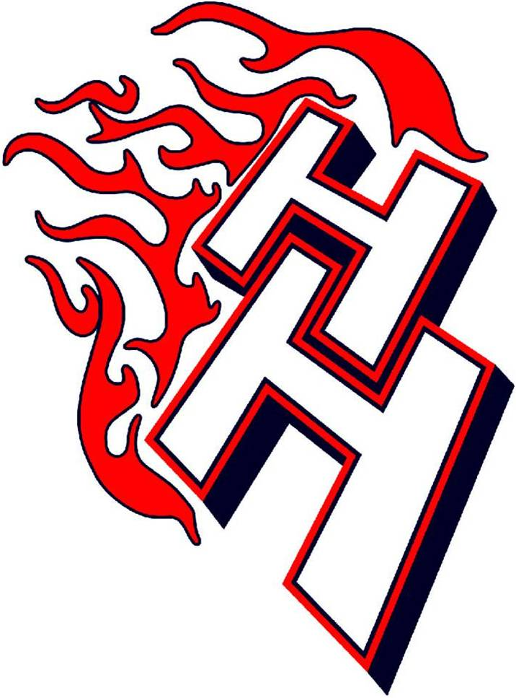

BOYS & GIRLS VARSITY BOWLING
Bus Depart
12/07 At Airport Lanes vs GL 3:15
12/08 At Hudson Lanes vs Addison 3:15
12/14 At Airport vs MC 3:15
01/02 At Marshall Lanes (tourney) 9:30 am
01/04 At Airport Lanes vs VCL 3:15
01/06 At Airport Lanes vs Manc 3:15
01/12 At L & J Lanes vs Jonesville 3:15
01/13 At Airport Lanes vs Nap 3:15
01/15 At Airport Lanes vs Jones/VCLTBA
01/20 At Surburban Lanes vs EJ 3:15
01/21 At Chelsea Lanes vs GL 3:00
01/24 At Airport Lanes (Mel Wolf) TBA
01/25 At Airport Lanes vs Addison 3:15
01/27 At Suburban Lanes vs MC 3:15
02/08 At Airport Lanes vs EJ 3:15
02/09 At Maplewood vs Manc 3:15
02/19 Universal Lanes (Conf. Team)TBA
02/20 At Airport Lane (Conf. Sing.) TBA
02/22 At Airport vs Napoleon 3:15
02/24 At Suburban Lanes vs EJ 3:15
02/26 At TBA (Team Regionals) TBA
02/27 At TBA (Ind. Regionals) TBA
03/04 At TBA (Team State) TBA
03/05 At TBA (Ind. States) TBA

VARSITY COMPETITIVE CHEER
12/12 At Homer Invitational 10:00 am No Bus
12/16 At East Jackson Jamboree 6:00 4:15
01/09 Hanover-Horton Invitational 10:00 am
01/11 Springport Invitational 6:30pm No Bus
01/13 At Michigan Center Jamboree6:00 4:15
01/20 At VCL Jamboree 6:00 4:15
01/27 H-H Jamboree ** 6:00
01/30 At Morenci Invitational 10:00am No Bus
02/10 At Conference @ Grass Lake TBA TBA
02/19-20 Districts @ TBD TBA TBA
02/27 Regionals @ TBD TBA TBA
03/04-05 State Finals @ Delta Plex TBA TBA
** Parents Night

VARSITY WRESTLING
12/09 At Concord 6:00 No Bus
12/12 At Concord Invitational 8:00am No Bus
12/16 Michigan Center (dual) 6:00
01/02 At Dan Taylor Invitational 9:30 am No Bus
01/06 At Quincy (Quad) 6:00 No Bus
01/13 Man/Nap/MC Quad ** 6:00
01/20 At Manc. Quad (vs EJ & GL) 6:00 4:15
01/27 At Add Quad(vs VCL & Add)6:00 4:30
01/30 At Jackson JAWS 8:00am No Bus
02/05 At Conference @ Addison 4:00 2:00
02/10 Team Districts @ VCL TBA
02/13 Ind. Districts @ Blissfield TBA
02/17 Team Regionals @ Clinton TBA
02/20 Ind. Regionals @ Bronson TBA
02/26-27 Team State Finals @ CMU TBA
03/03-05 Individual State Finals @ The Palace TBA
** Parents Night

