SMILES ON WHEELS
AT
SCHOOL

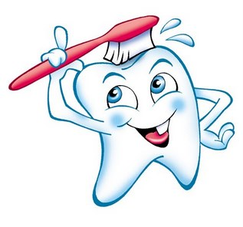

Dental care for students is available at school!

The past several years, we have been fortunate enough to be able to provide dental care at school for those students who do not have a primary dentist.
Smiles on Wheels is a mobile dental program that can provide services like;

Oral Screenings
Dental Cleaning
Fluoride
&
Sealants.

The dates that Smiles on Wheels will be in our district are as follows

Thursday, November 5th – ELEMENTARY BUILDING
Monday, November 16th – HIGH/MIDDLE SCHOOL

Forms were sent home with elementary students, but extras are available in the office if needed.
Forms for the high school and middle school are available in the school offices.

If you have any questions, please call our offices.

